### **Objective**

The goal of this project was to create a virtualized cybersecurity lab consisting of:

* A Windows 10 virtual machine with Splunk and Sysmon for log analysis.
* A Kali Linux virtual machine to act as an attacker system.

### **Tools and Technologies Used**

* **VirtualBox**: Open-source virtualization software.
* **Windows 10 ISO**: For creating a Windows virtual machine.
* **Kali Linux ISO**: For penetration testing.
* **Splunk & Sysmon**: Security monitoring tools.

### **Step 1: Installing VirtualBox**

1. Downloaded VirtualBox from [VirtualBox.org](https://www.virtualbox.org/) that is compatible with my OS in this case Windows.

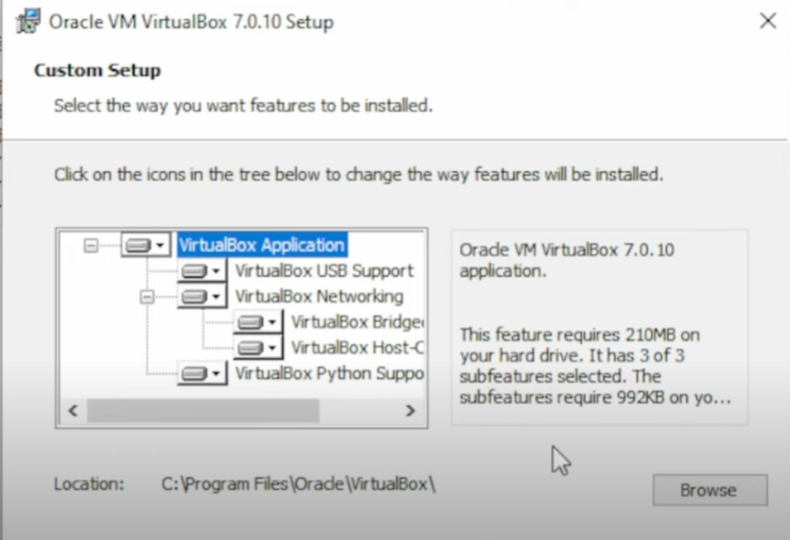

For the setup of VirtualBox I keeped the same settings

### **Step 2: Setting Up the Windows 10 Virtual Machine**

1. Downloaded the **Windows 10 Media Creation Tool** and generated a Windows 10 ISO.

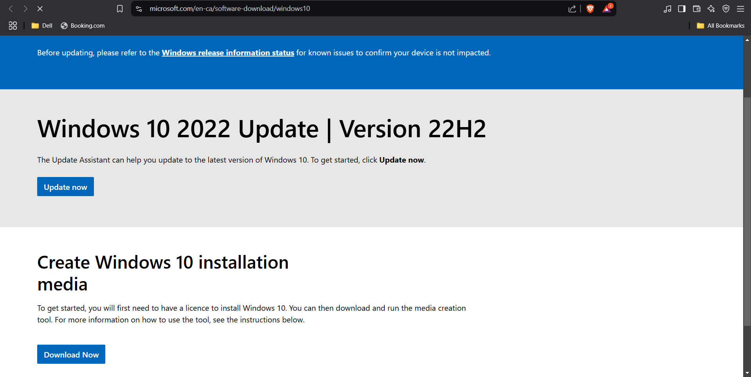

After this I accepted license terms and then chose Create Installation Media. I used to use ISO file media and it was downloaded.

2. Created a new virtual machine in VirtualBox:

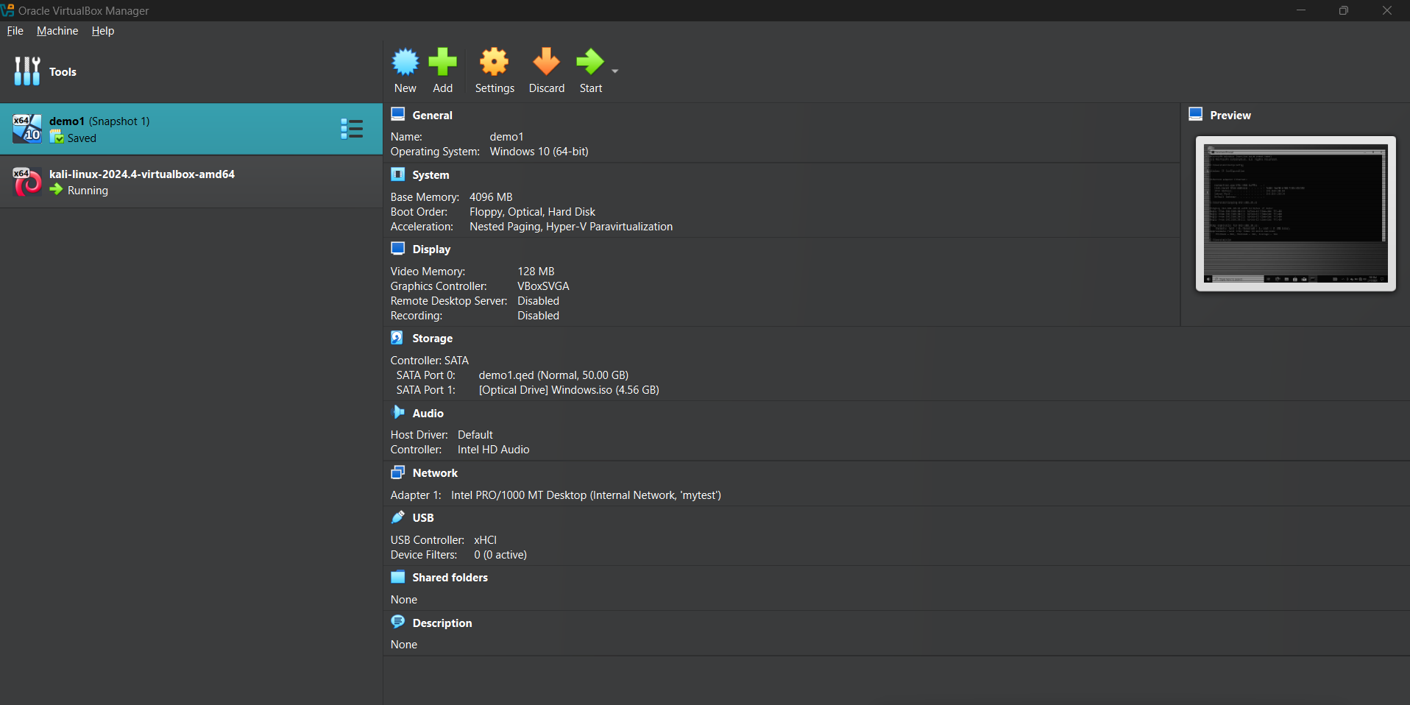

I clicked on New and then.

* + Assigned 4GB RAM and 50GB storage.
  + Mounted the Windows 10 ISO as the boot disk.
  + Configured network settings for internet access.

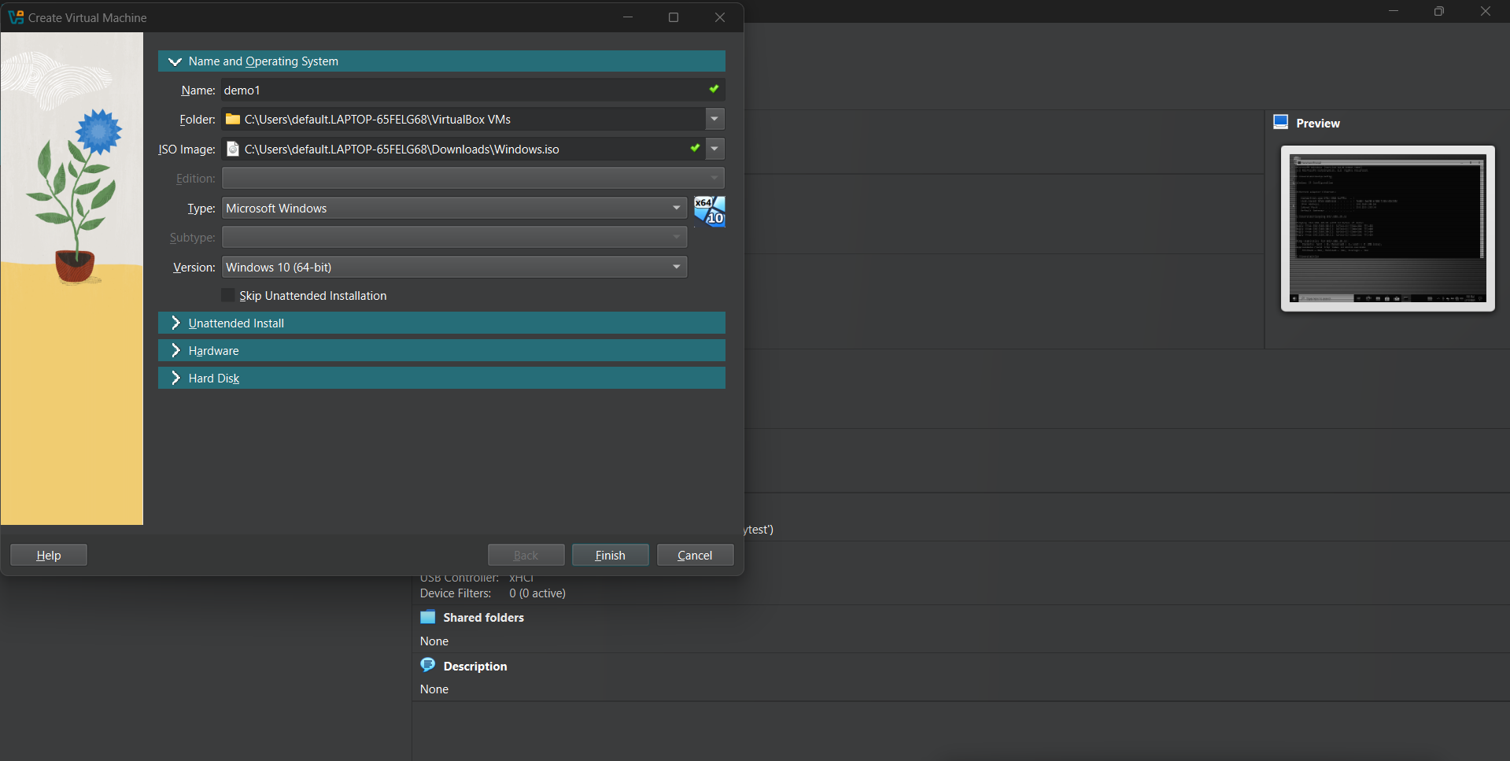

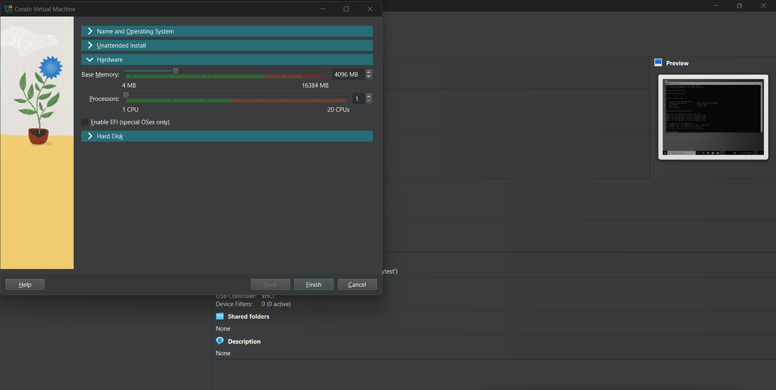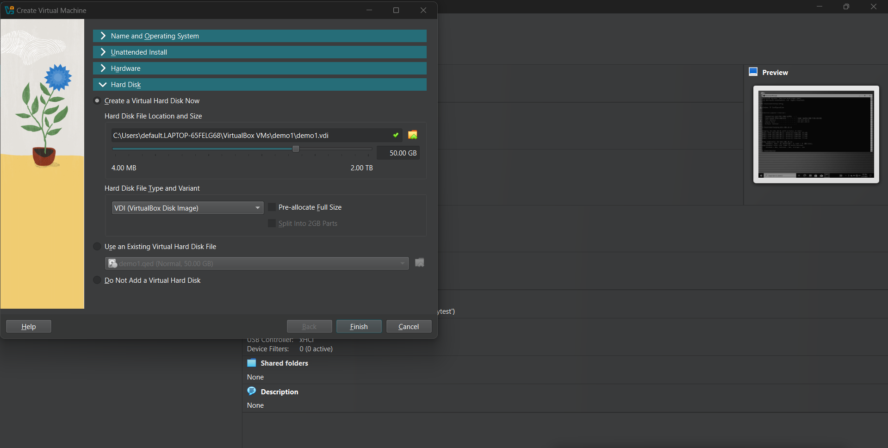

This was the final configuration. After this I clicked Start and configured time and language settings. On the Windows activation I chose I don't have a Product Key and for the OS I chose Windows 10 Pro.

3. Installed Windows 10 and set up administrative credentials.

4. Installed **Splunk** and **Sysmon** for security monitoring.

**Step 3: Downloading Splunk**

Step 1:Through my web browser I went to [Splunk’s official website.](https://www.splunk.com/) I hovered over Products in the top menu and clicked Splunk Enterprise, clicked Free Trial, signed up for a Splunk account and once signed in, located Splunk Enterprise on the download page. Selected Windows as the operating system and clicked Download, accepted the Terms and Conditions, then clicked Access Program. After that I just waited for the download to complete.

Step 2:

To begin the installation, I opened File Explorer and navigated to the Downloads folder, where the Splunk installer file is located. Windows security prompts a confirmation, and I clicked Run to proceed with the installation. Upon reaching the License Agreement screen, I review and accept the terms before continuing. The installer will then present an option to use the default installation path or specify a custom location. I decided to continue with the default config and clicked Next.

Step 3:

During the configuration phase, the user will be prompted to select an account type. Since this installation is for a local setup, I chose Local System. I assigned a Username and a strong Password. To finalize the setup, I clicked Next and allowed the installation process to run, which may take approximately 5 to 10 minutes. Once completed, the Launch Splunk Enterprise option has to be checked before clicking Finish to complete the installation.

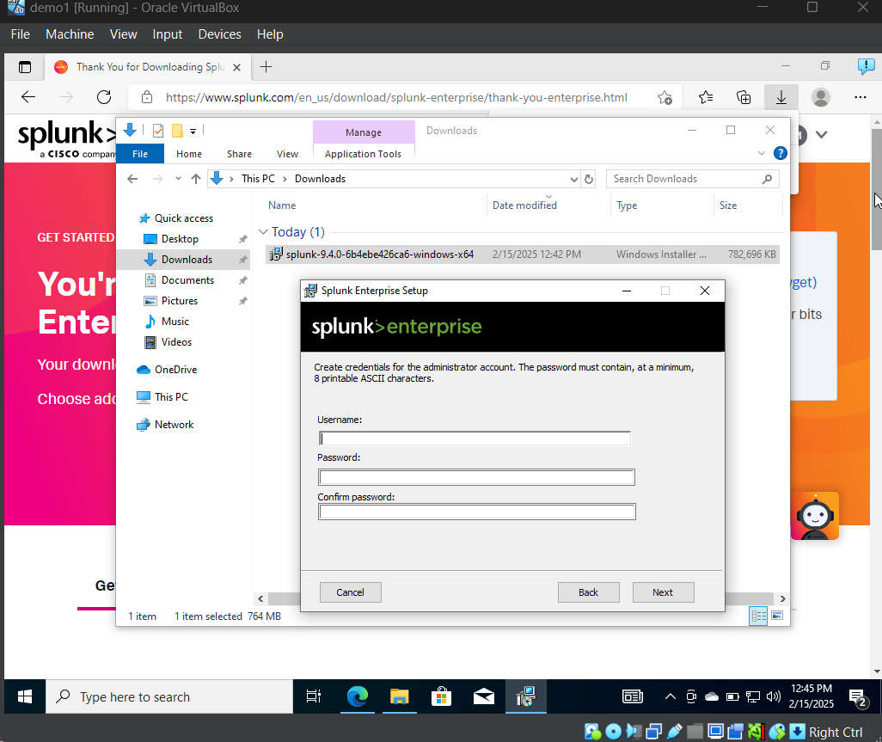

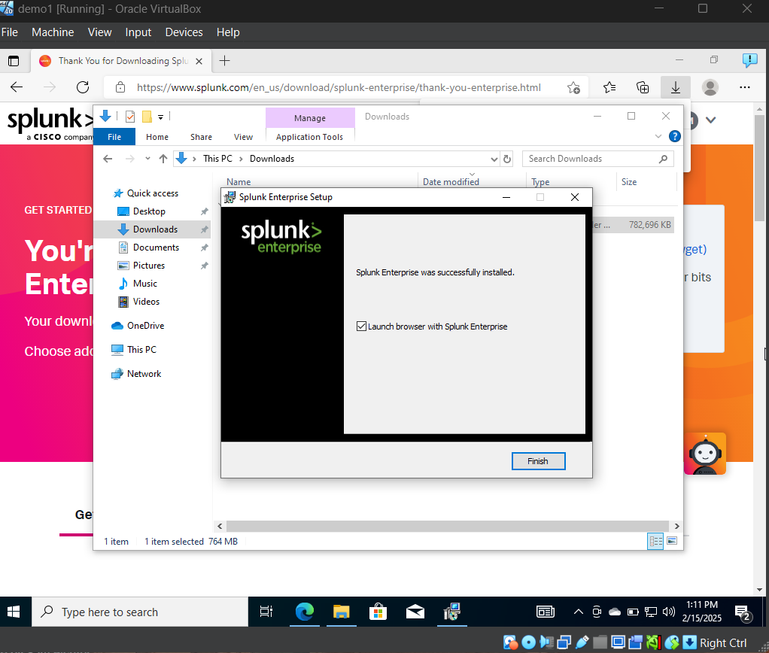

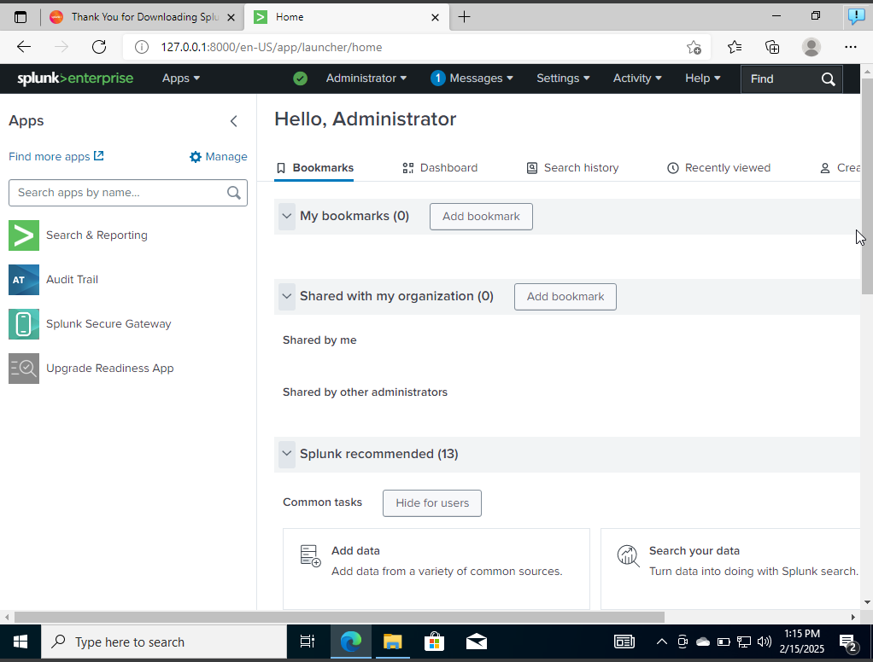

**Downloading Sysmon**

I started by downloading Sysmon from the official Microsoft Sysinternals website and chose the Download Sysmon for Windows and downloaded Sysmon configuration from GitHub. After Sysmon was downloaded I extracted it.

I opened PowerShell as an Administrator and ran cd “path of my folder” and then I ran dir in order to see the files on the folder and ran .\Sysmon64.exe. To check if Sysmon was correctly installed, I went into the start menu and clicked Services to see if Sysmon was running on my computer and it was not so I opened PowerShell and ran .\Sysmon64.exe -i .\sysmonconfig.xml and after I ran this the License and Agreement appeared and Sysmon was successfully downloaded. To make sure Sysmon was running I went into Services again and this confirmed it was running.

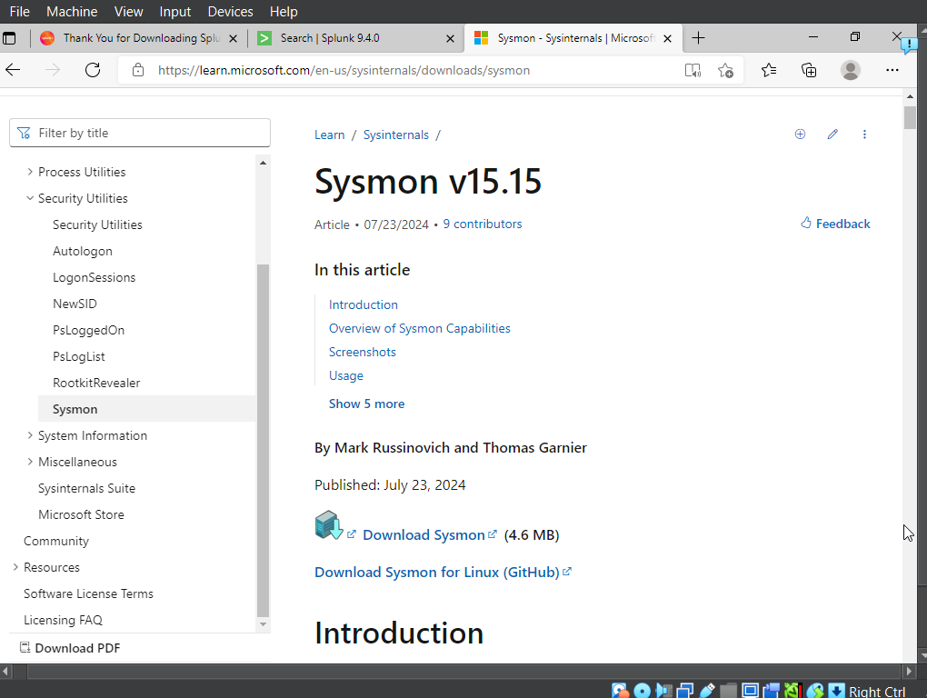

GitHub sysmon configuration.

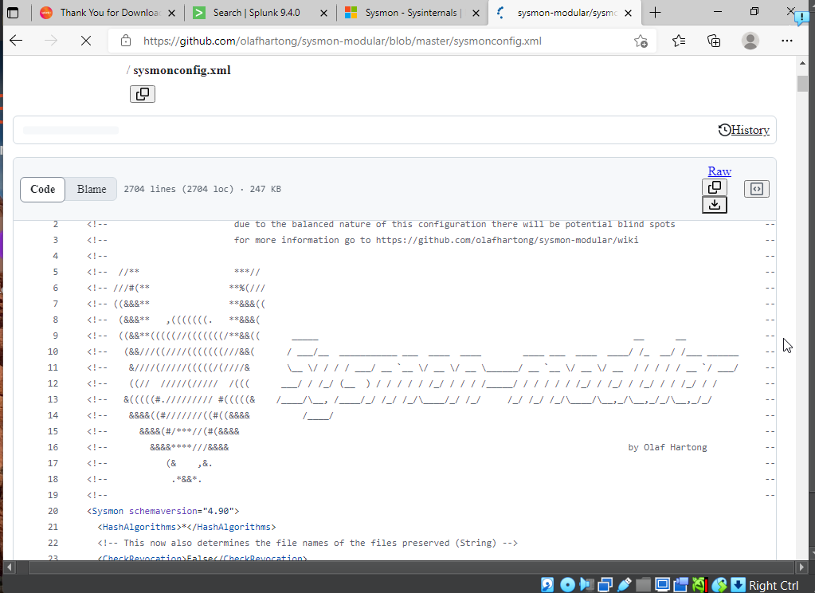

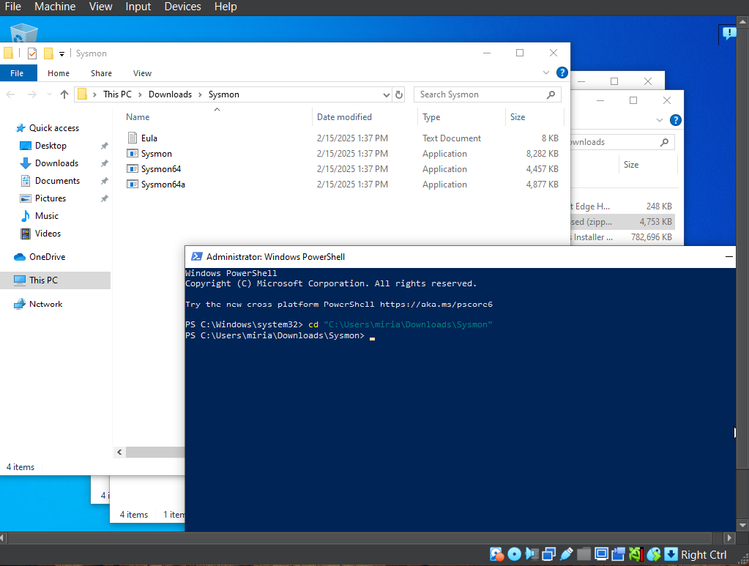

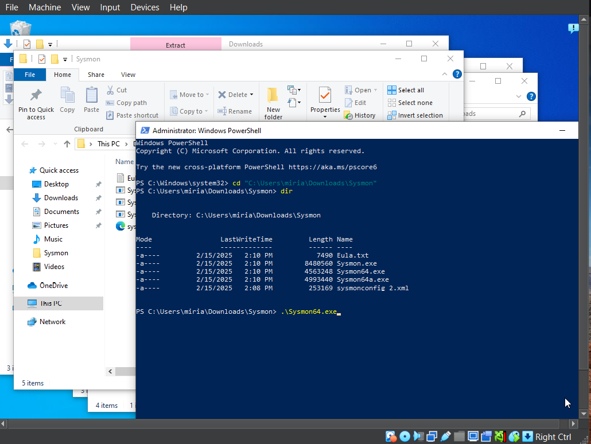

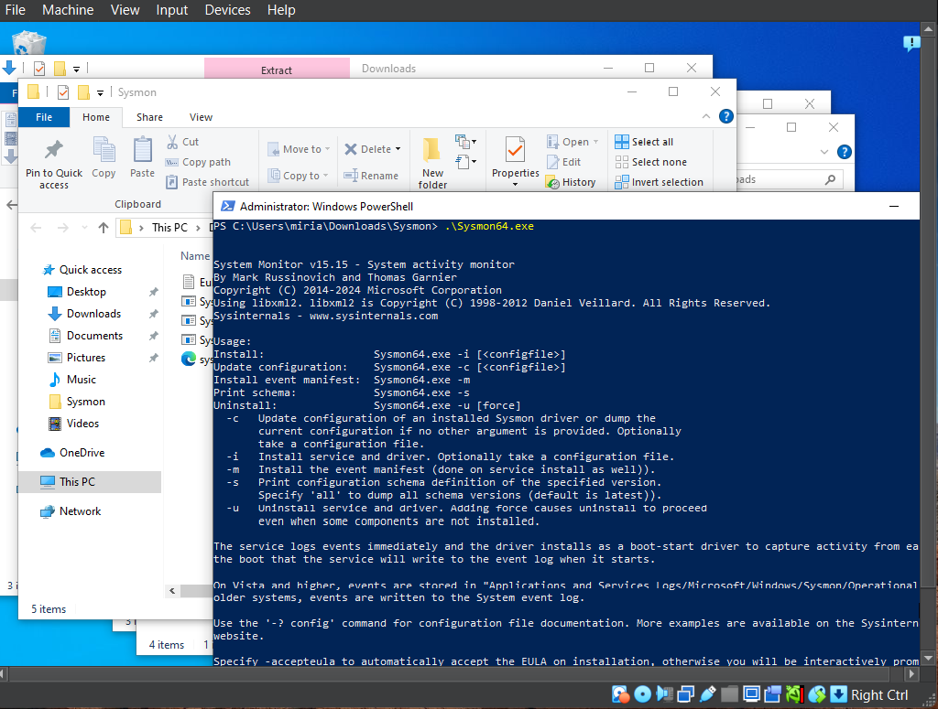

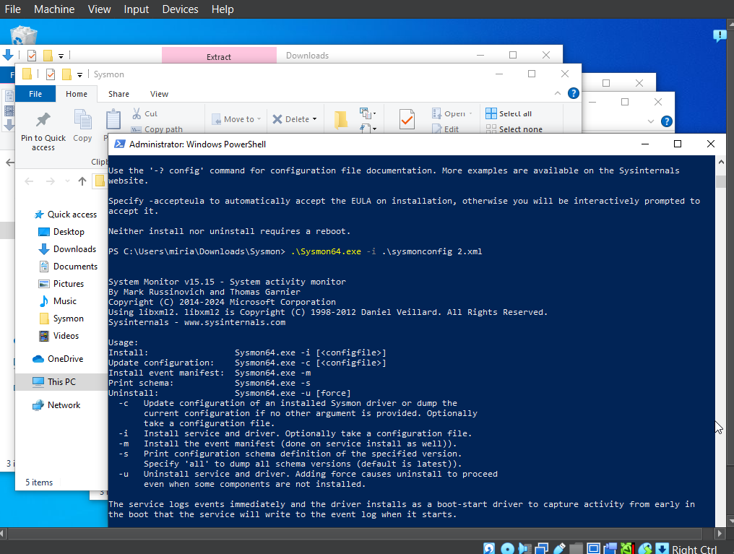

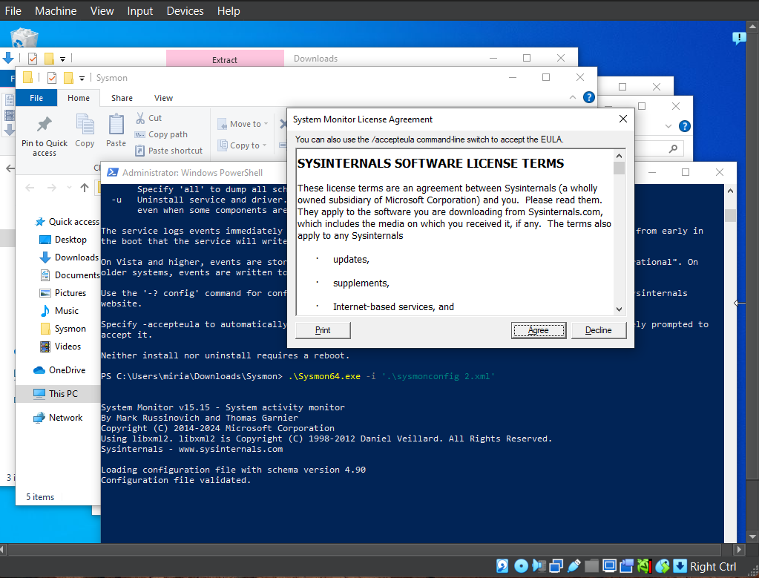

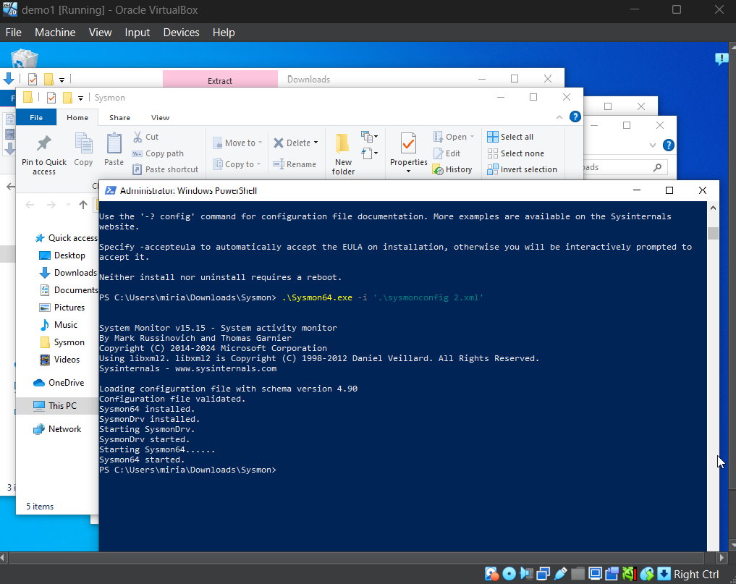

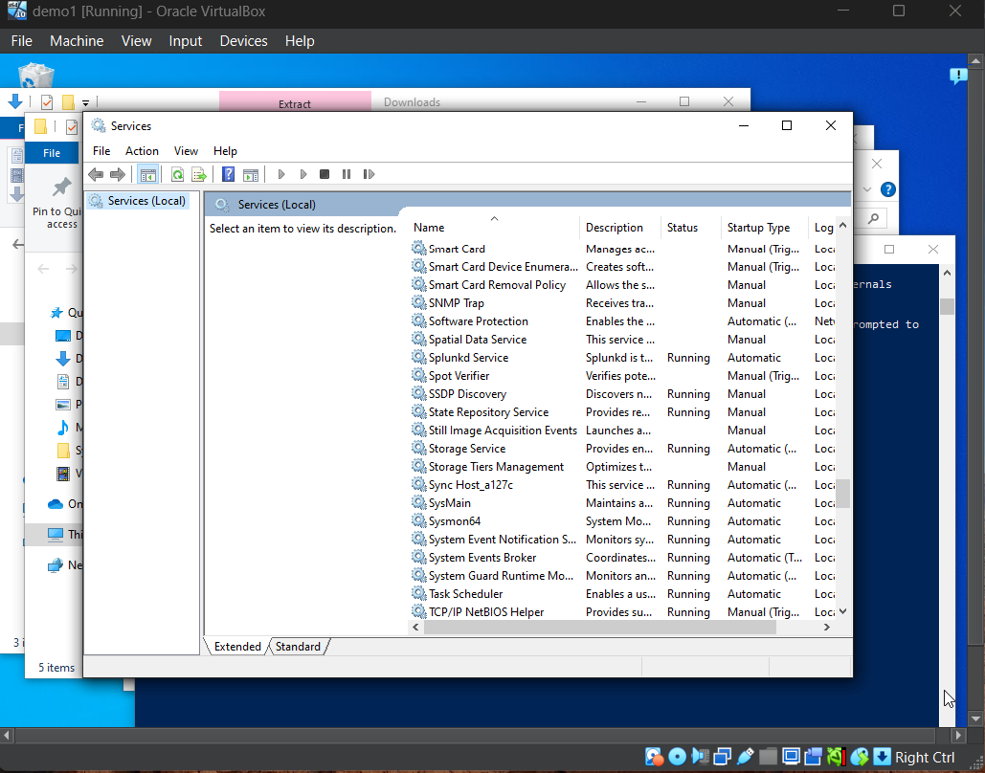

**Downloading Kali**

I went into [Kali.org](http://kali.org) and downloaded Kali for virtual machine

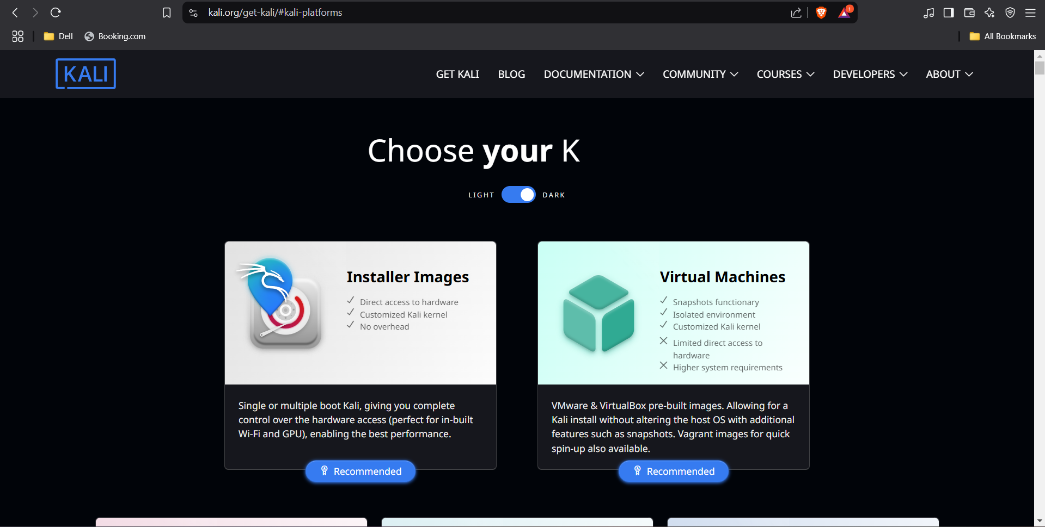

I also went ahead and downloaded 7zip of 64bit as Kali is a 7zip file extension.

After everything was downloaded I extracted the Kali file using 7zip, I clicked the Kali folder, chose the VBox file and it was automatically downloaded into VirtualBox.

**My Home Lab Configuration**

**Note:** Default virtual machine settings can pose a risk to the host system when handling malware. To minimize this risk, network configurations must be carefully adjusted.

Just to test tools with internet connectivity default settings would work (this would use NAT).

If using my Home Lab for Malware Analysis is safer not to use an internet connection, be on its own network or not even attach a network adapter to it.

In my case for this Home Lab I chose the second option and these are my configurations:

For Windows 10

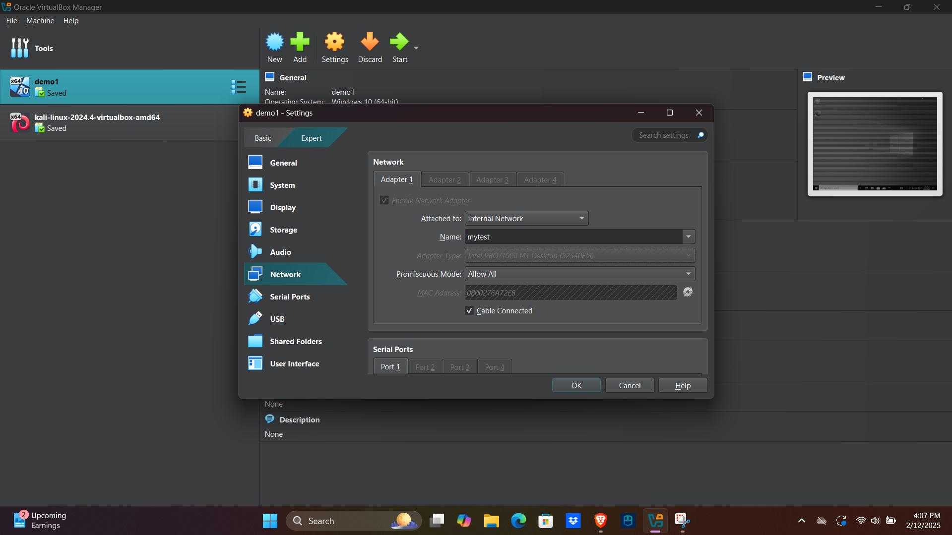

For Kali:

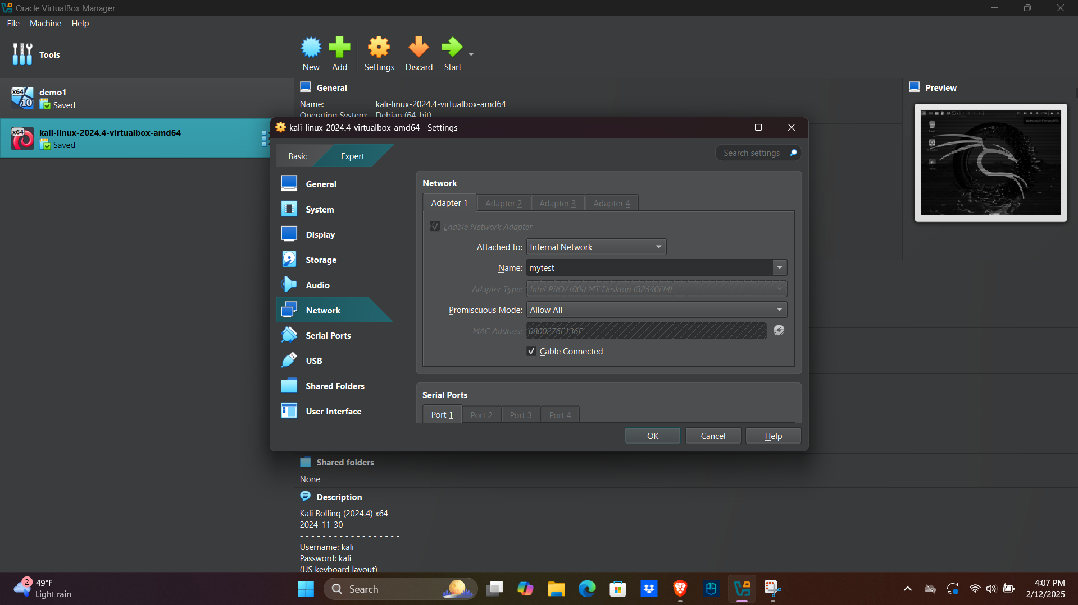

Here is a summary of my configurations:

Windows



Kali:

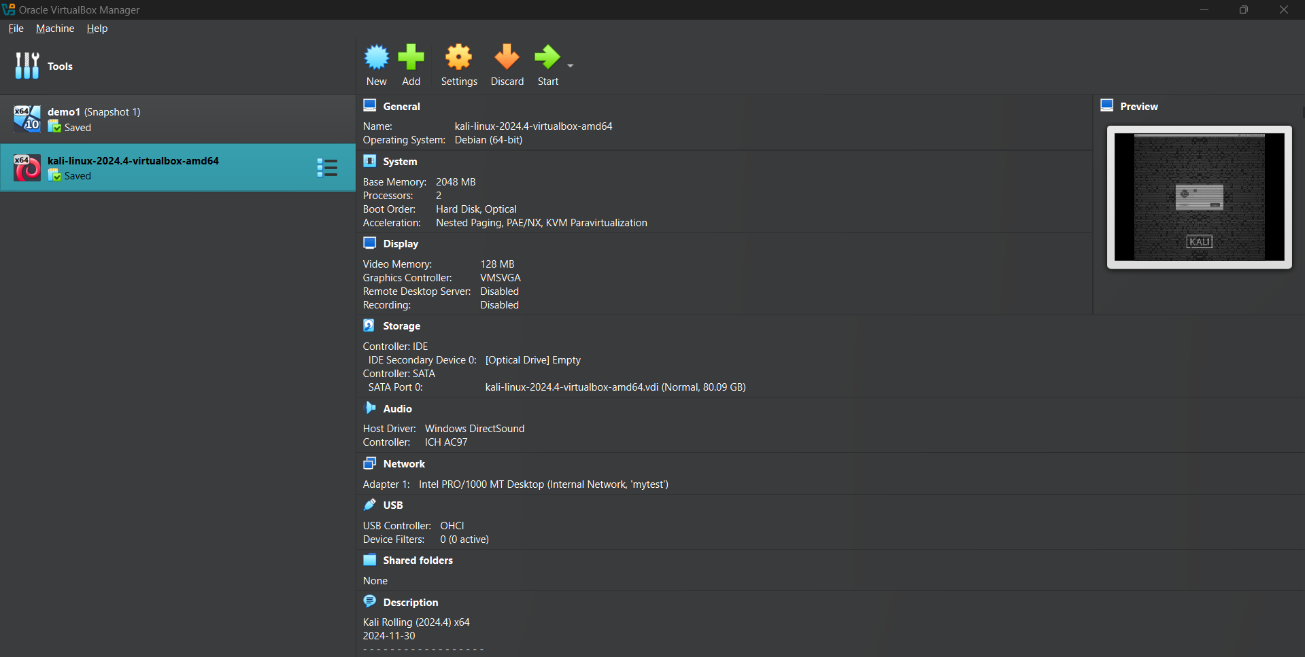

Now that both machines are on the same network, we need to assign static IP addresses to ensure stable communication and here is how I did it.

**For Windows:**

1. Click on the globe and then click on Network & Internet settings.

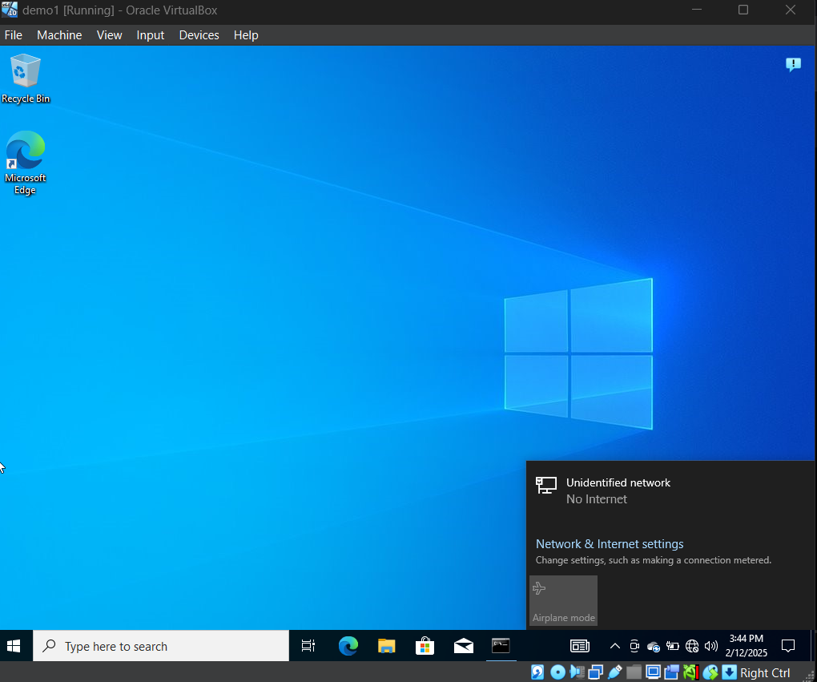

1. Clicked on Change adapter options.

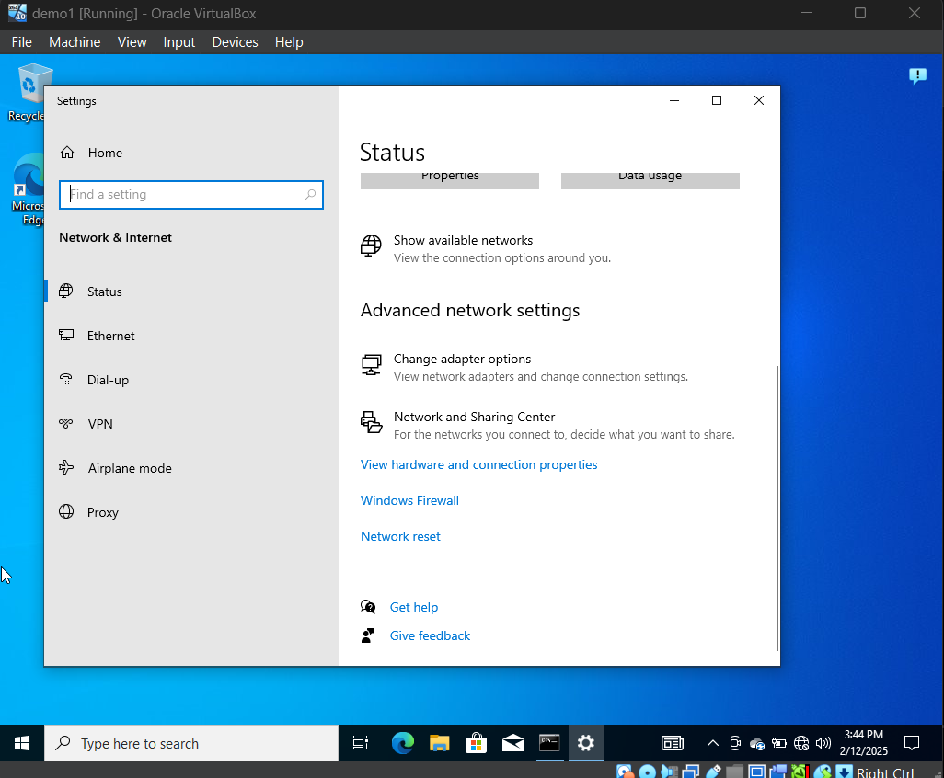

1. Double-clicked on Ethernet and then clicked on Properties

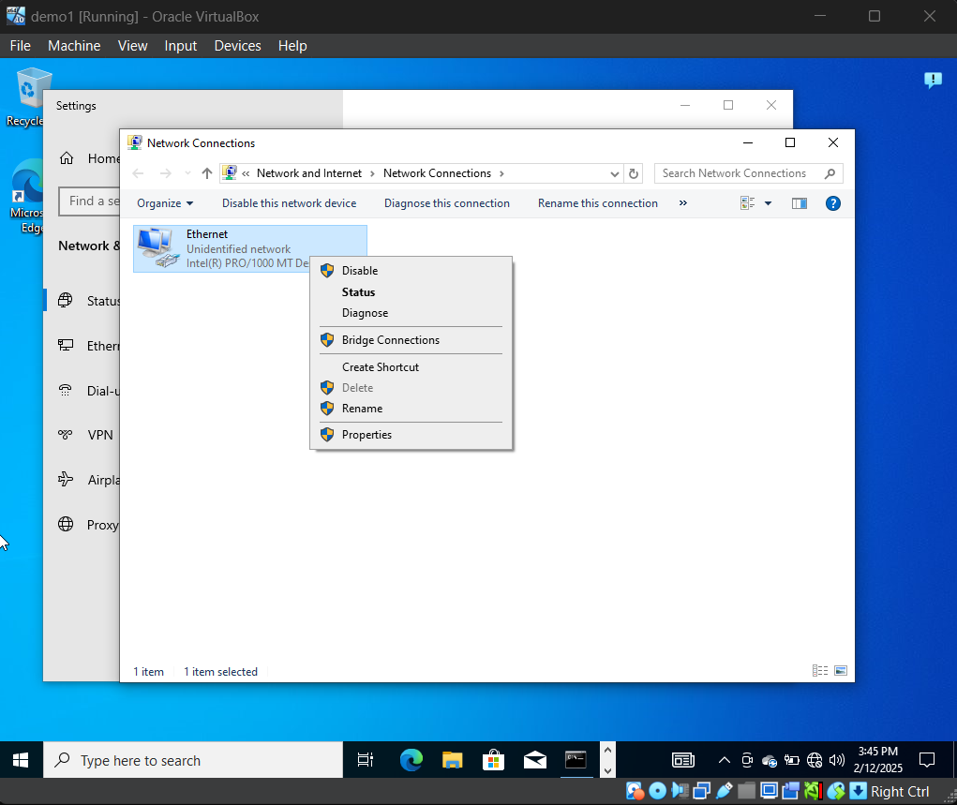

1. Look for Internet Protocol Version 4, Select it and click on Properties.

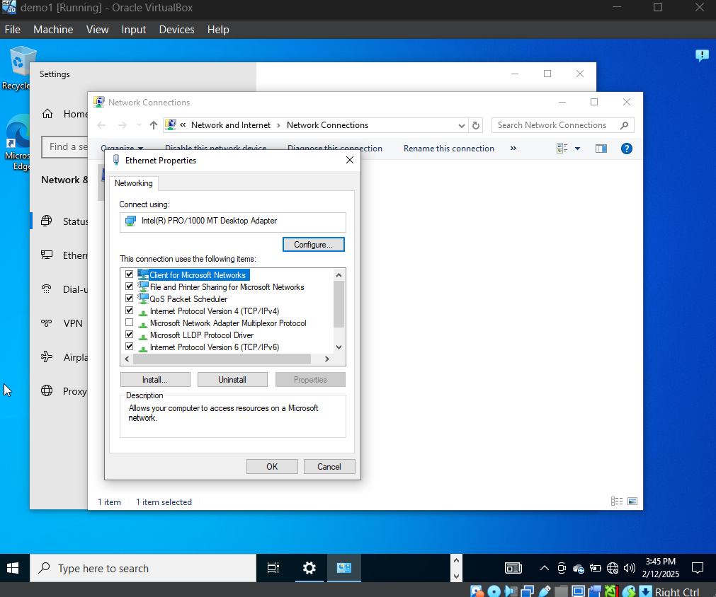

1. Switch to Use the following IP address to static assign IP address and Subnet Mask.

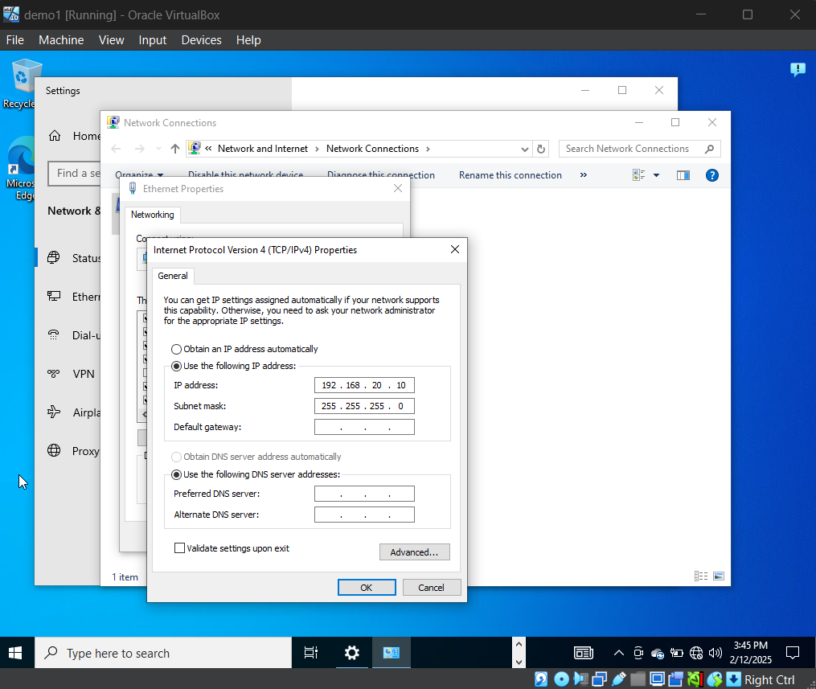

1. In order to verify the change, open the command prompt and run ipconfig.

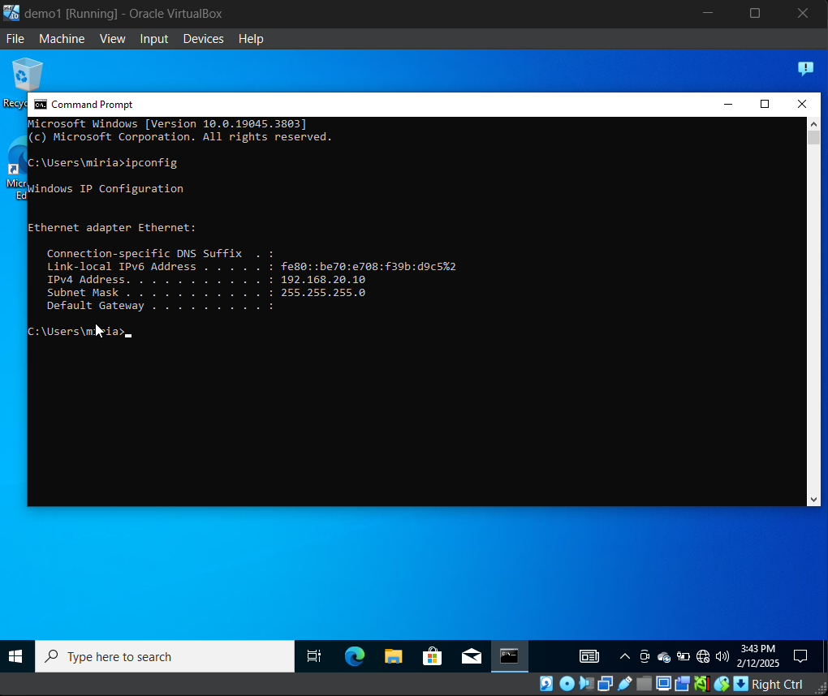

**For Kali:**

1. Clicked in the Ethernet icon and double clicked Wired connection 1

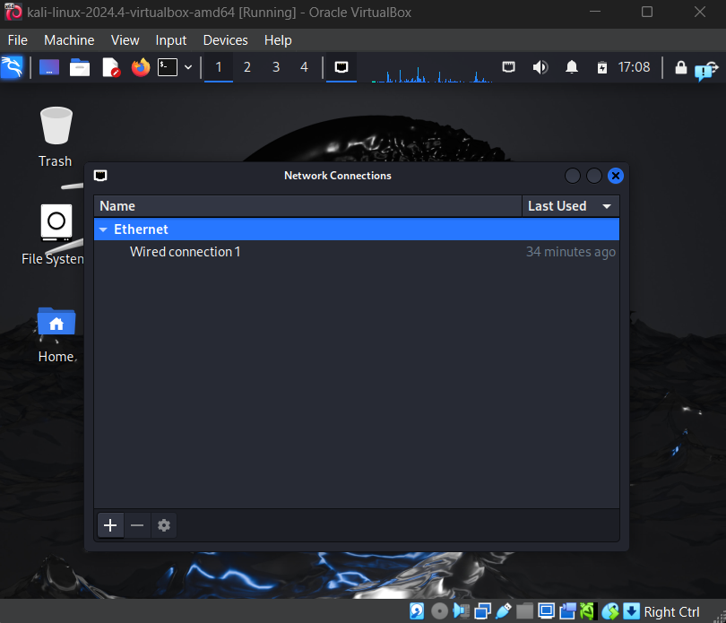

1. Select IPv4 settings and assigned the following Address and Netmask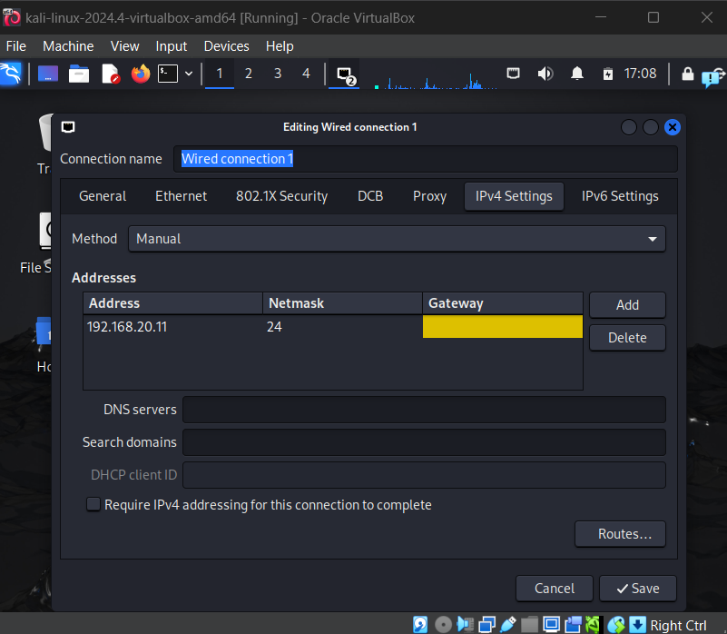
2. Right-clicked anywhere in the screen and clicked Open Terminal Here and ran ifconfig to make sure changes are saved.

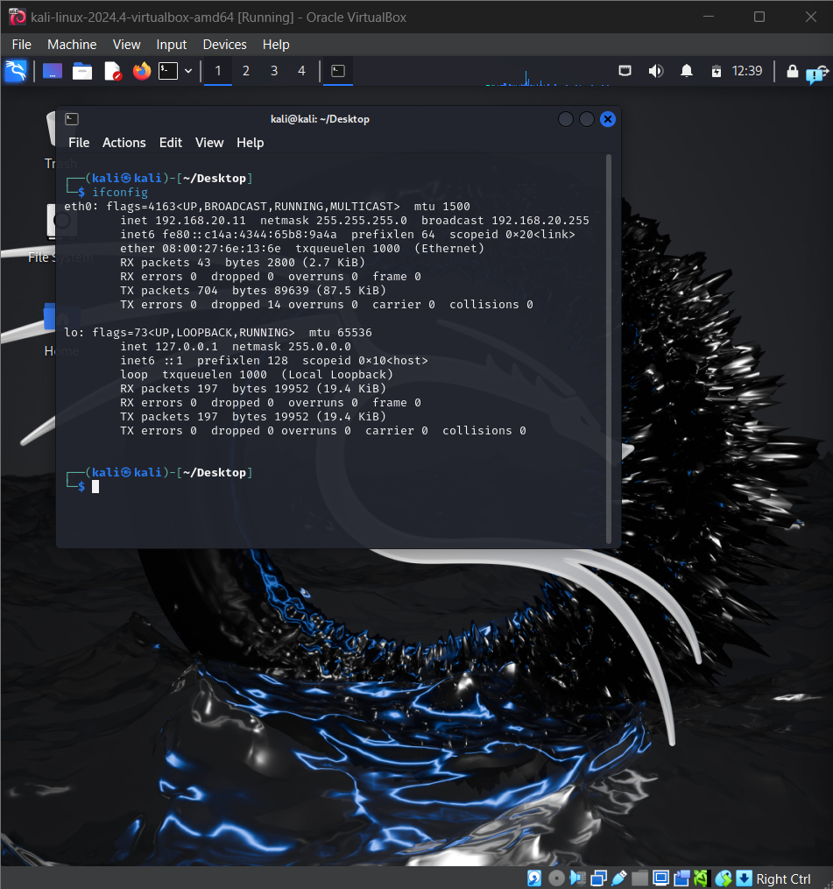

Now let’s ping our Kali machine from Windows to confirm connectivity.

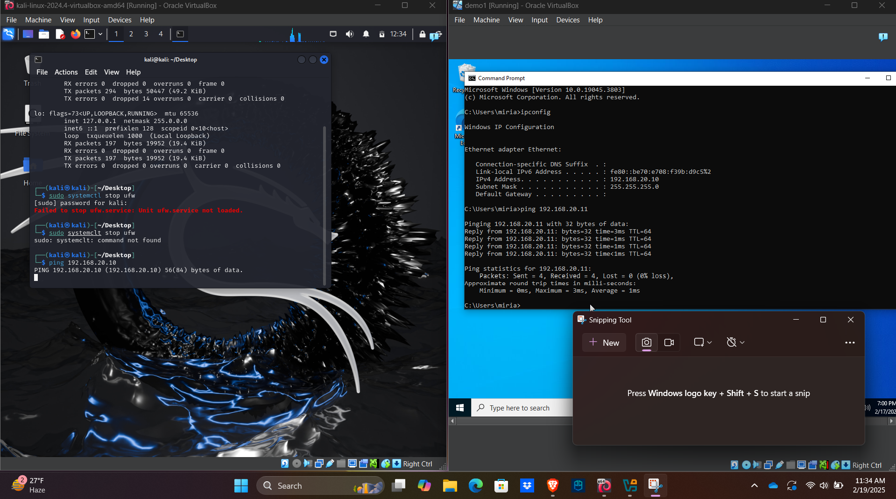

After doing this, I went ahead and started using Nmap to detect any open ports on my victim’s machine. I ran nmap -h.

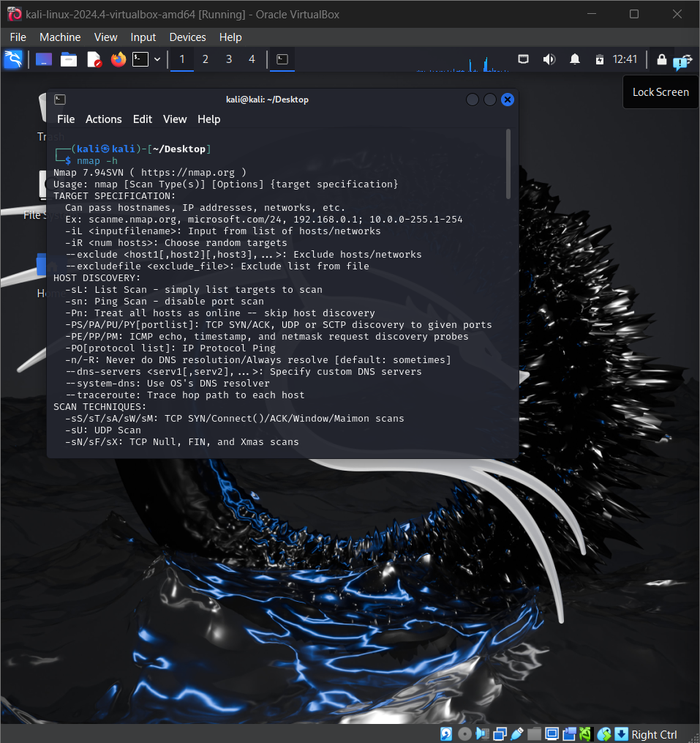

Then I ran nmap -A 192.168.20.10 -Pn (this is my victim’s IP address).

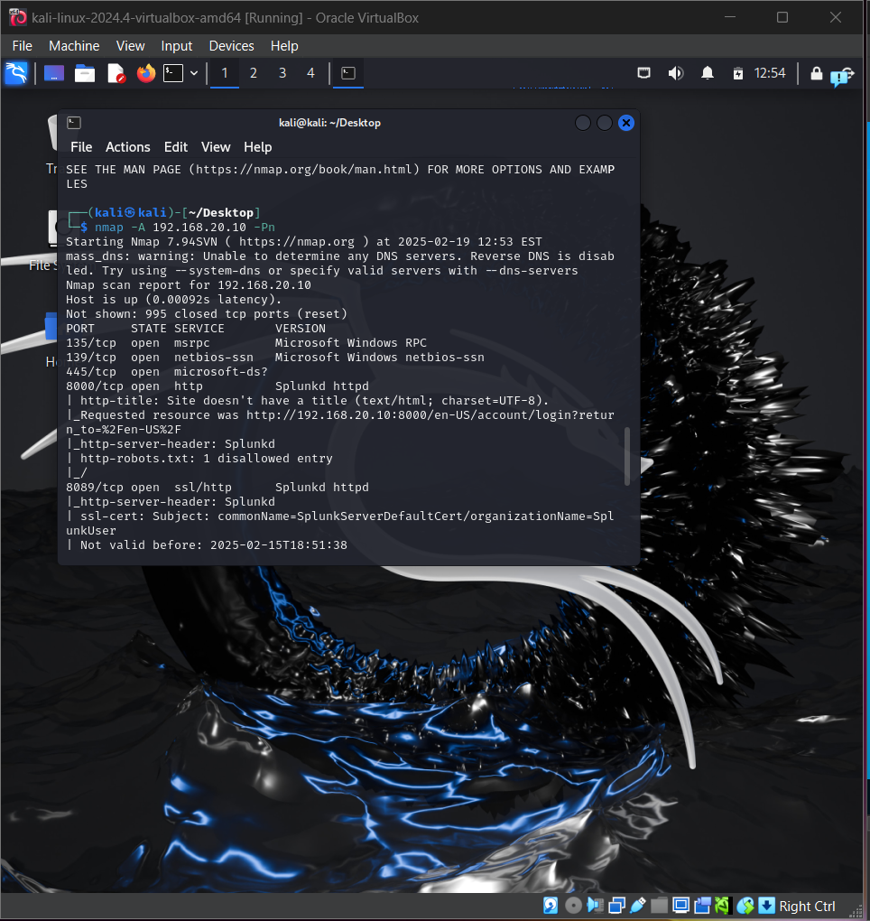

And those ports shown above are the open ports on my victim’s machine, in this case port 135/tcp, 139/tcp, 445/tcp, 8000/tcp.

I noted this information and started creating my malware using the command msfvenom.

Note: This time we are not focused on how to build malware to avoid detection, we are focused on generating telemetry to see how it looks on our Windows machine.

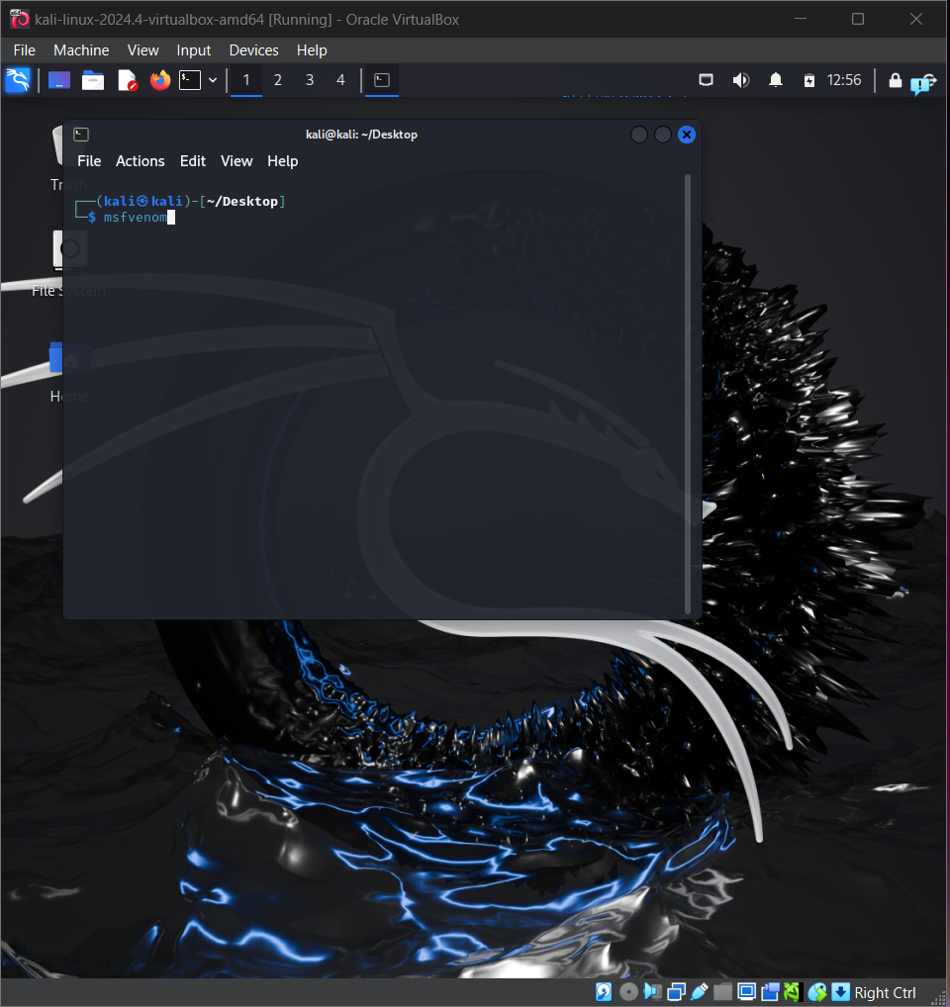

And then ran msfvenom -l payloads

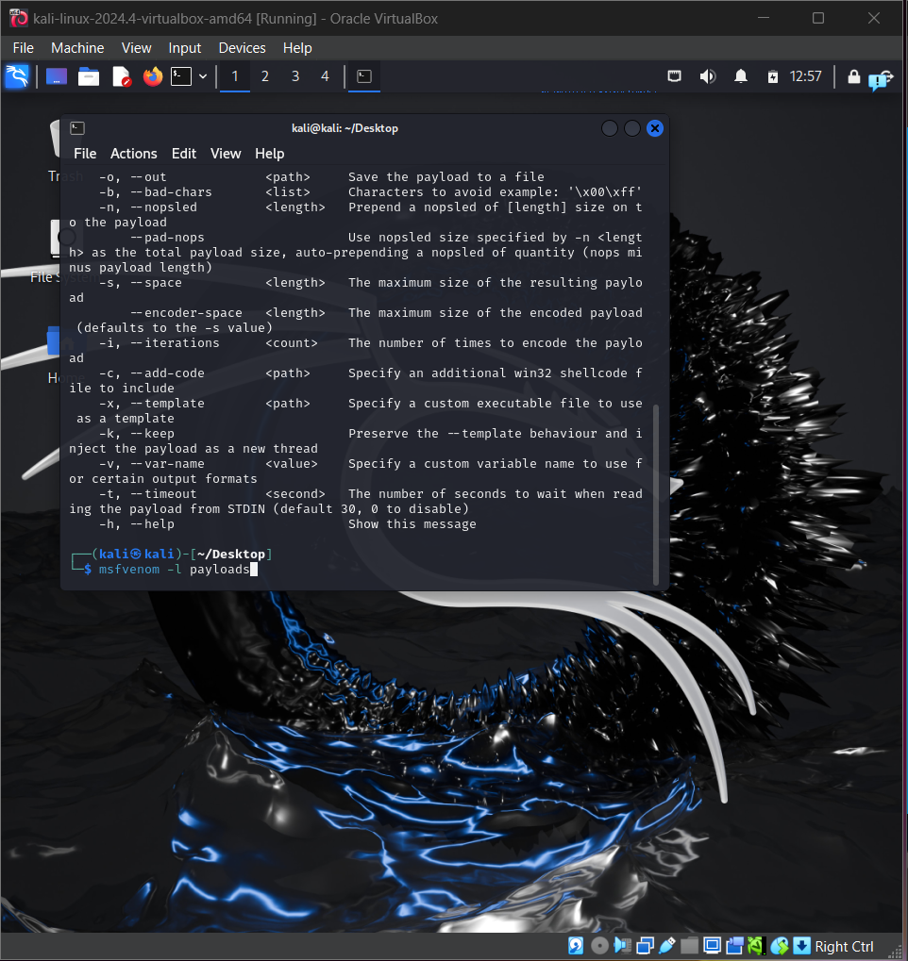

This will show me all the payloads allowed.

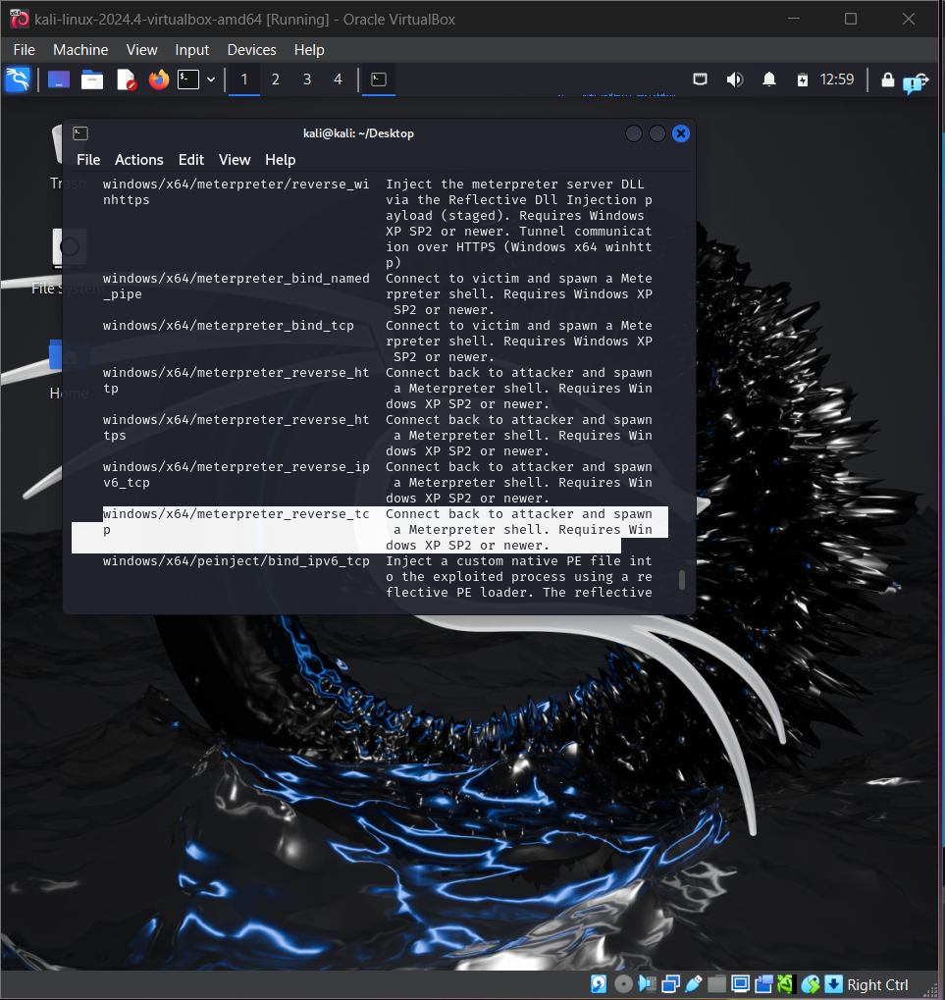

I went ahead and used **windows/x64/meterpreter_reverse_tcp** which will allow us to connect back to the attacker and spawn a Meterpreter shell; so I ran:

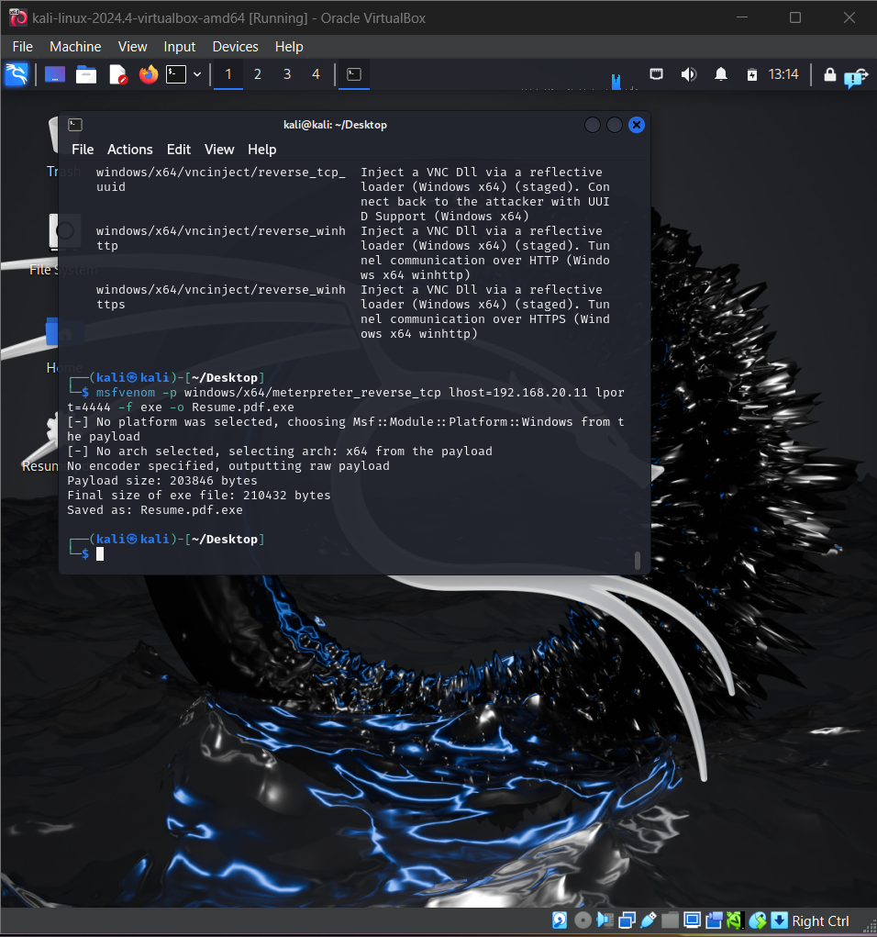

This command will basically create our malware using meterpreter reverse tcp payload which will connect back to our machine based on lhost and lport, the format will be an exe and the name will be Resume.pdf.exe.

After this I ran ls to make sure our file exists and then ran file Resume.pdf.exe to see what type of file that is.

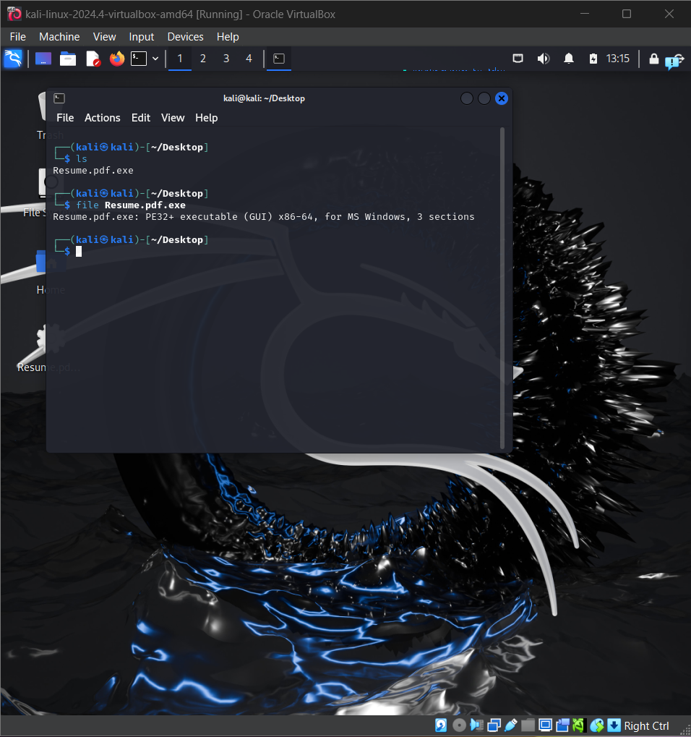

After this I opened a handler using metasploit which will listen in the port I configured for the malware; for this I ran msfconsole and then ran use exploit/multi/handler.

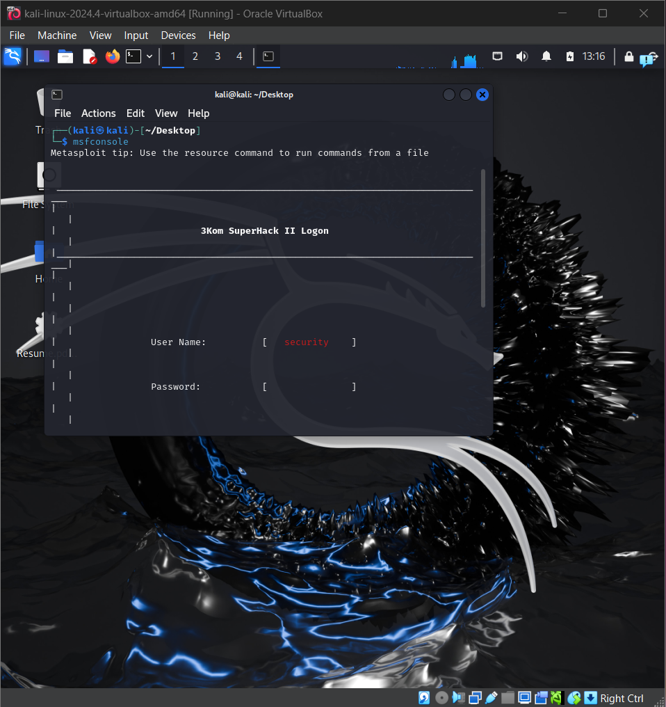

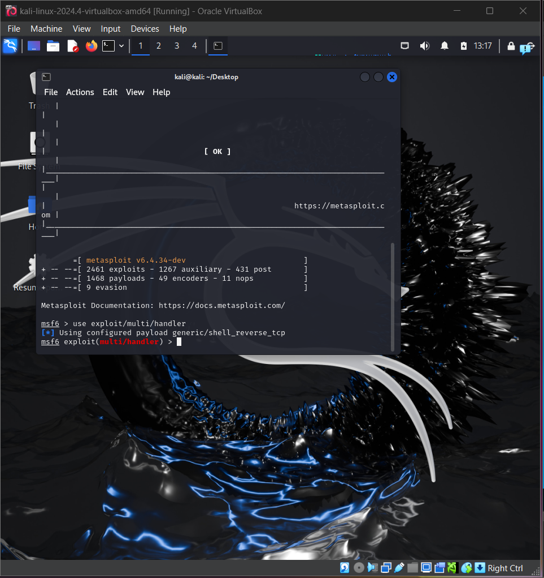

After this I ran options to see what I could configure.

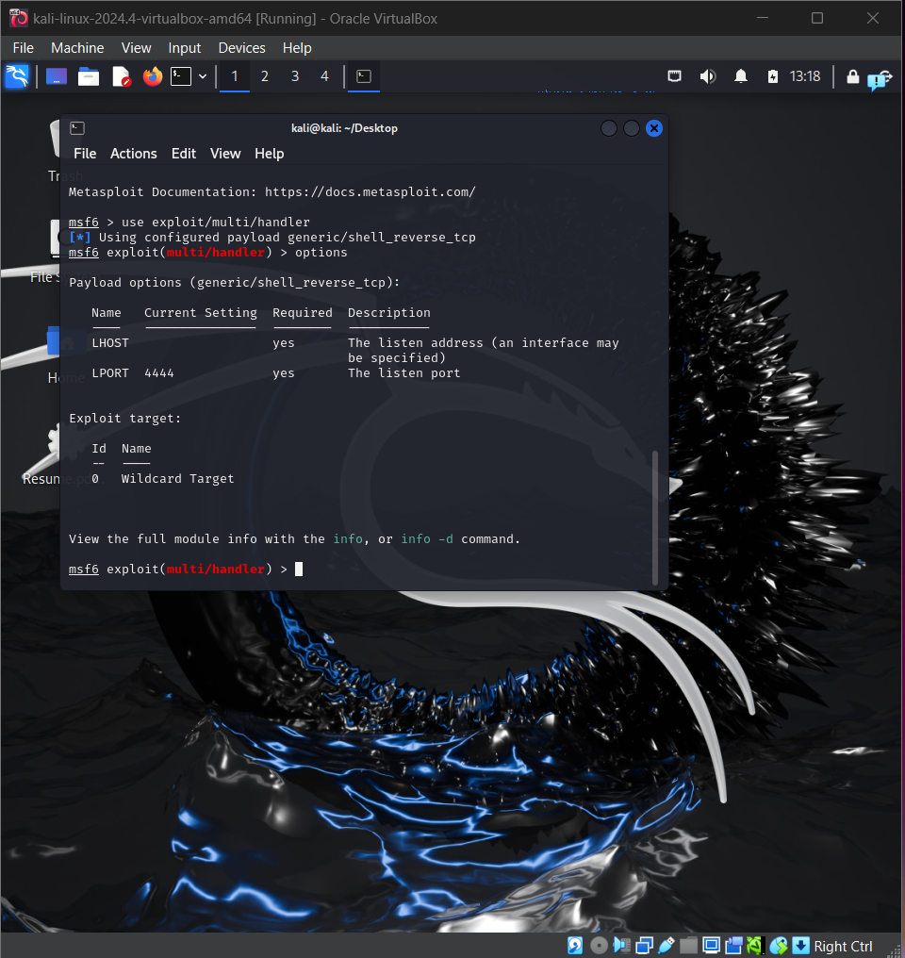

I noticed that the payload is configured to generic/shell_reverse_tcp so I went ahead and ran set payload windows/x64/meterpreter_reverse_tcp in order to change it to my desired option.

After this I ran options again to make sure it was changed and, it was changed.

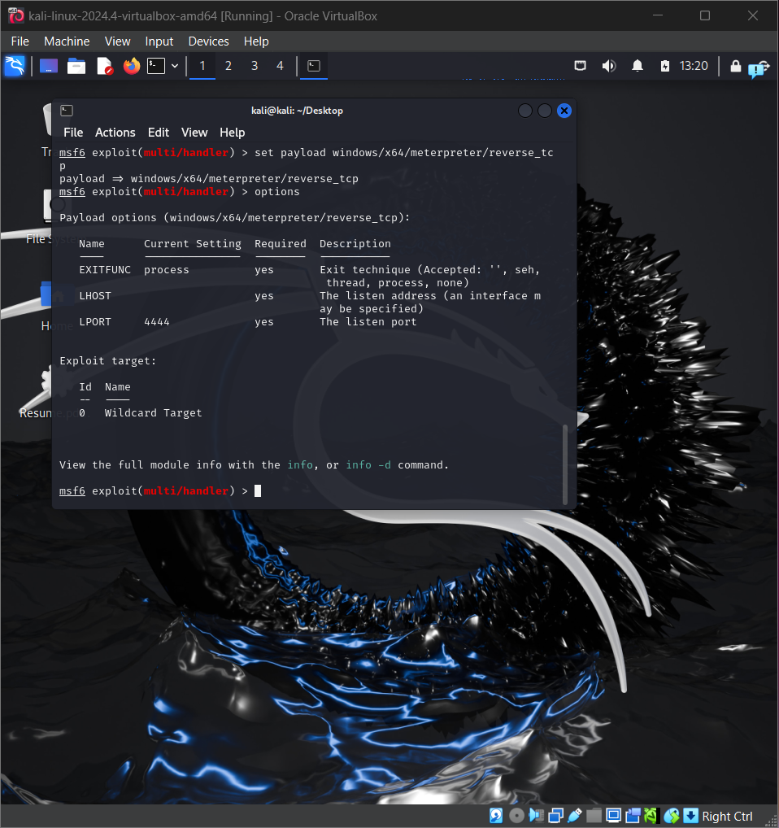

Then I focused on lhost and set it to my host, in this case my Kali machine, I ran set lhost 192.168.20.11 and ran options to make sure it was properly changed.

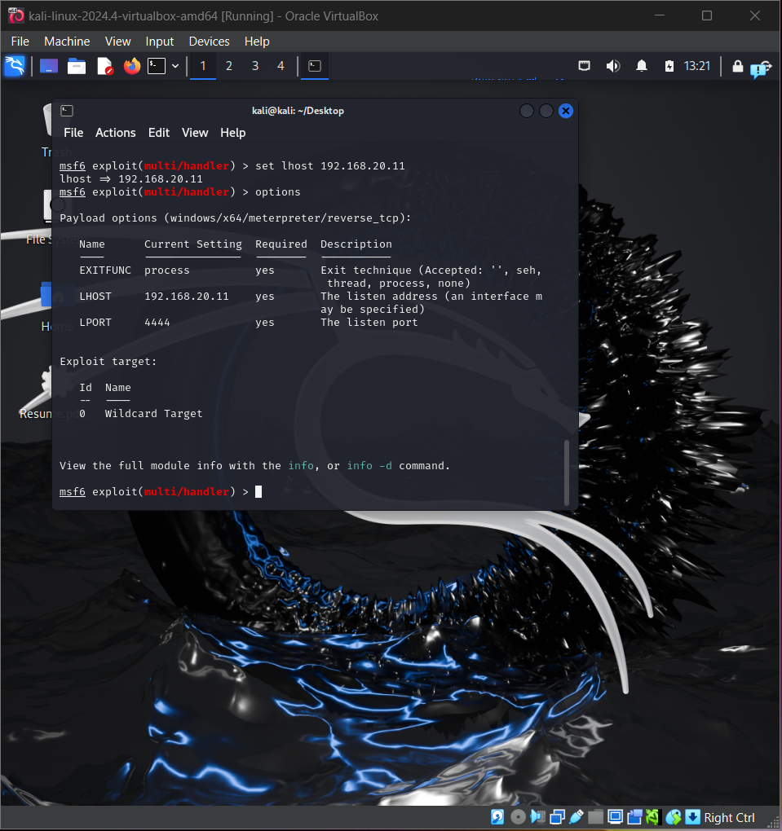

After this changes I started my handler my running exploit and as soon as that, i was listening into my Windows VM

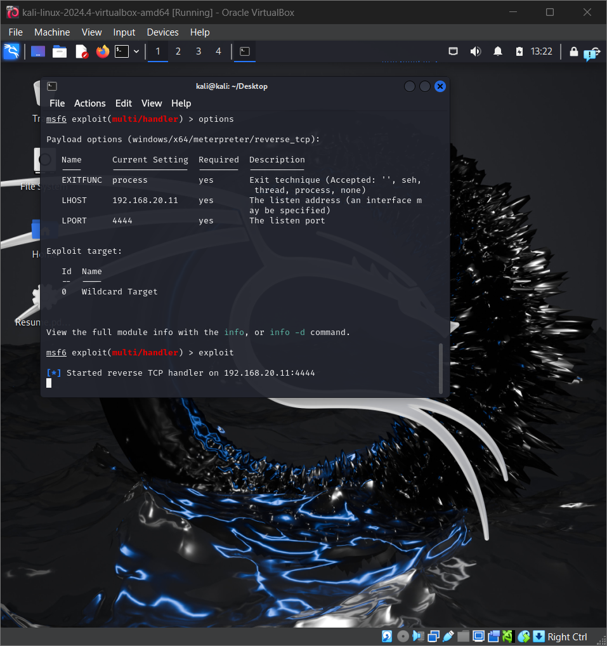

I also set up a HTTP server on my Kali machine so my victim can download the malware, I did so by using Python3 by running python3 -m http.server 9999.

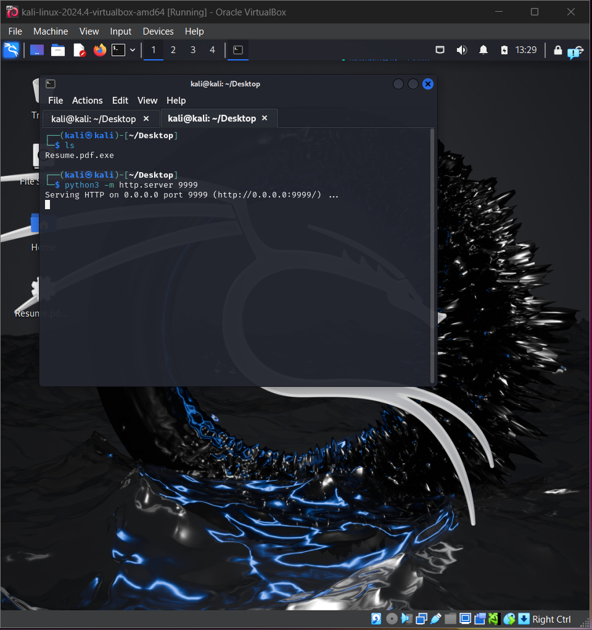

For the second part of this project I shifted over to my Windows machine and disabled Windows Defender so I am able to download and execute my malware.

I searched for 192.168.20.11:9999 and found my malware there, I downloaded it and clicked on keep so it can be downloaded even though it contains malware.

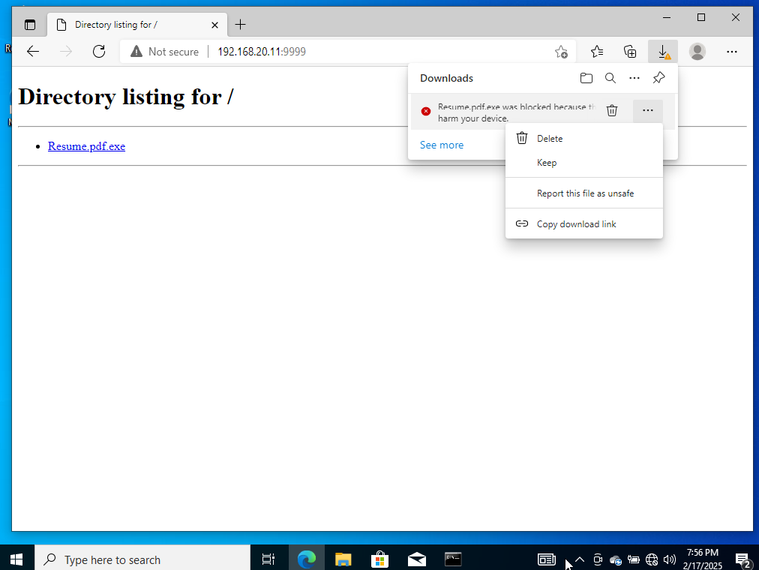

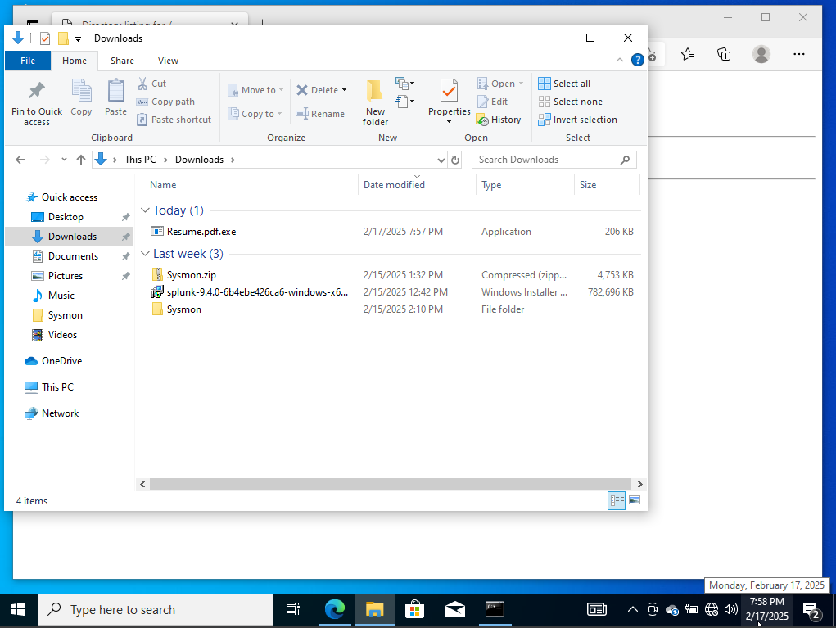

This is what happens if I try to open it, I clicked Run  
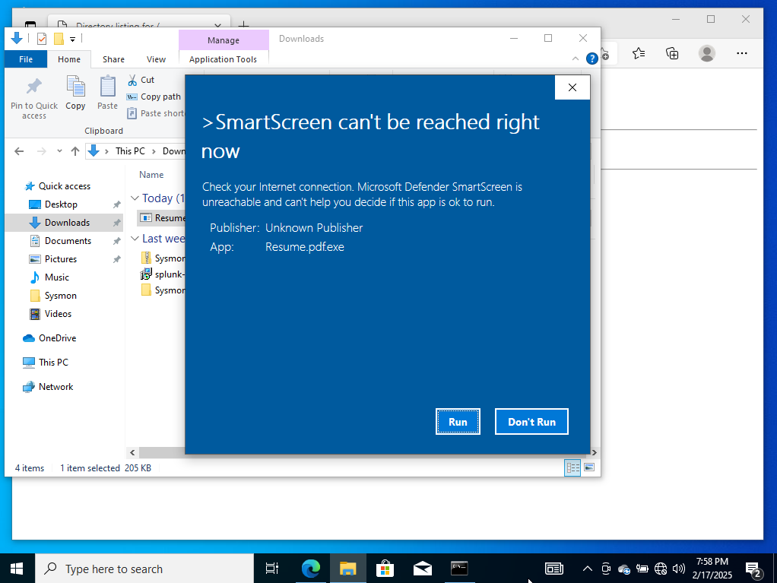

After this I opened Command Prompt and ran netstat -anob to see if there is an established connection to my Kali machine and there was.

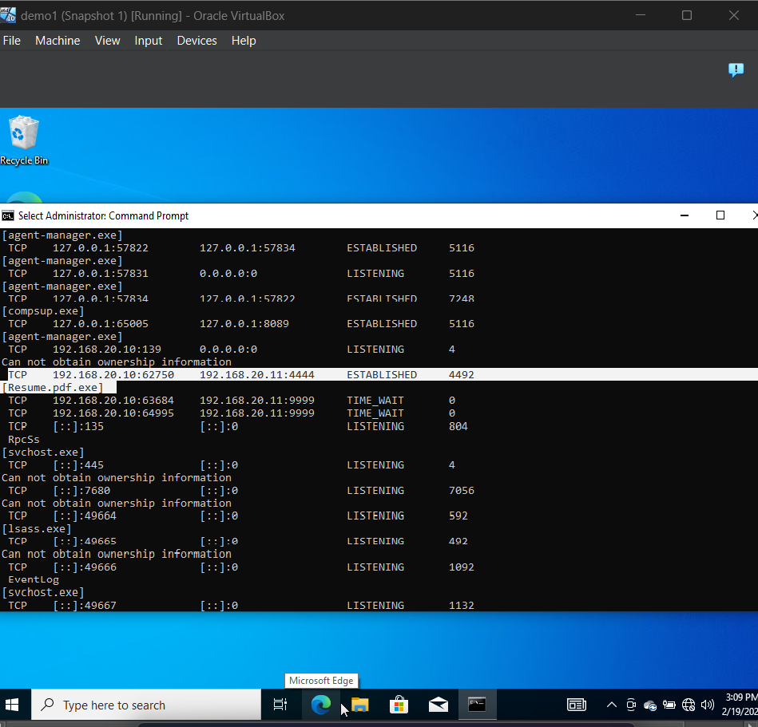

Here it is an established connection to 192.168.20.11 on port 4444 with a process ID of 4492; I opened Task Manager and went into details and searched for the same process ID to find out if it was running and it was.

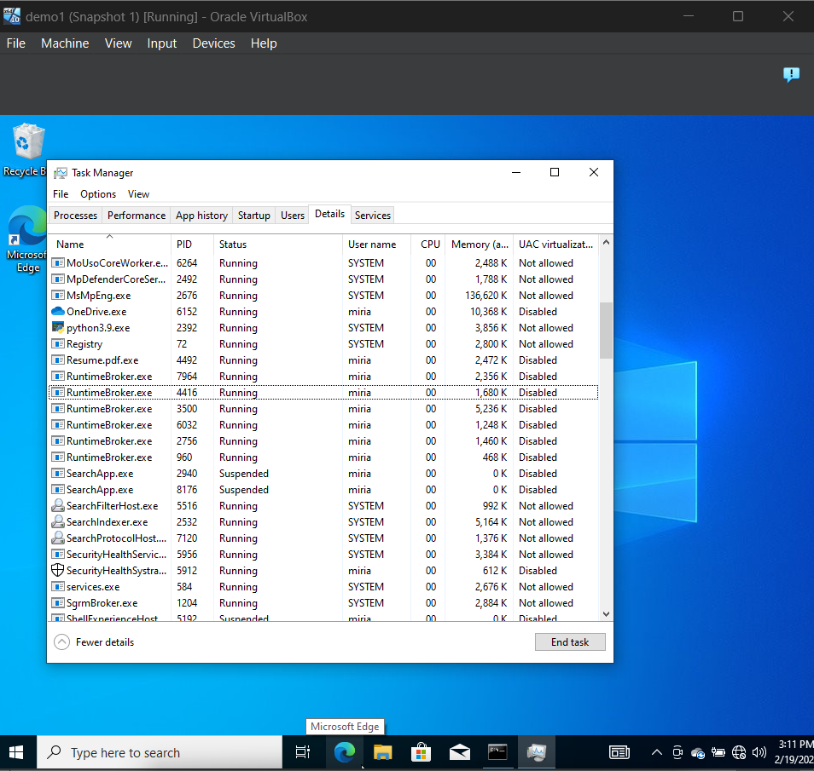

I went into Kali and I had an open connection, I ran shell to establish a shell on my test machine, then I ran net user, net localgroup as well as ipconfig

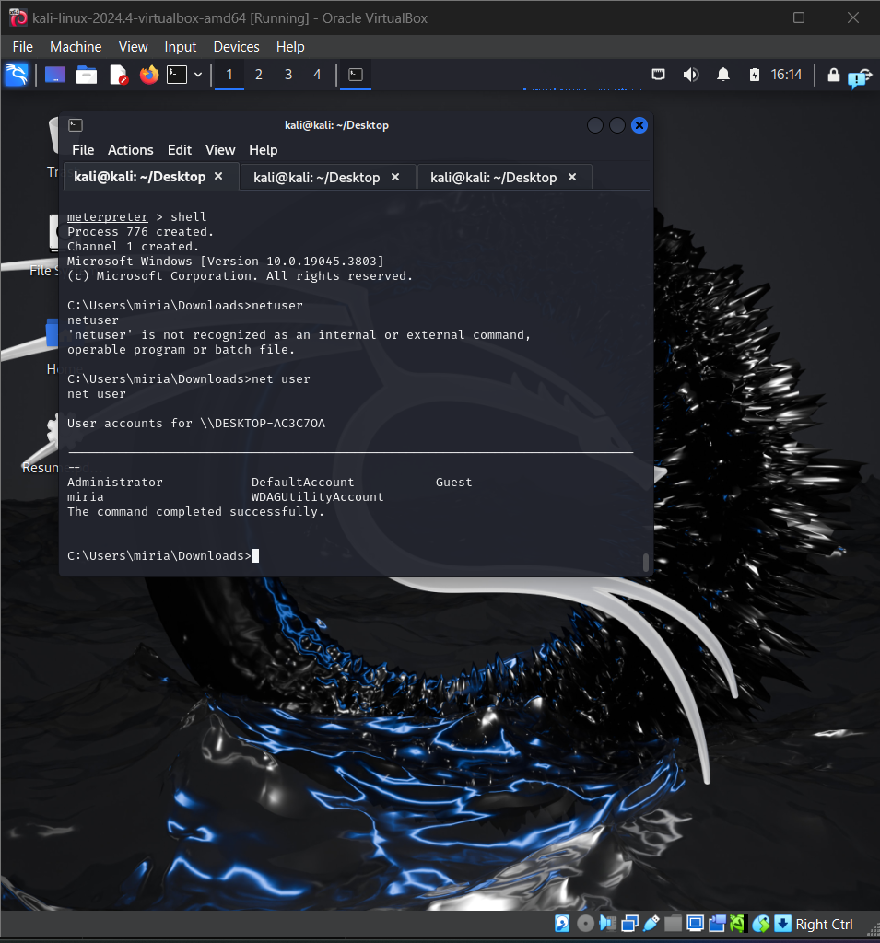

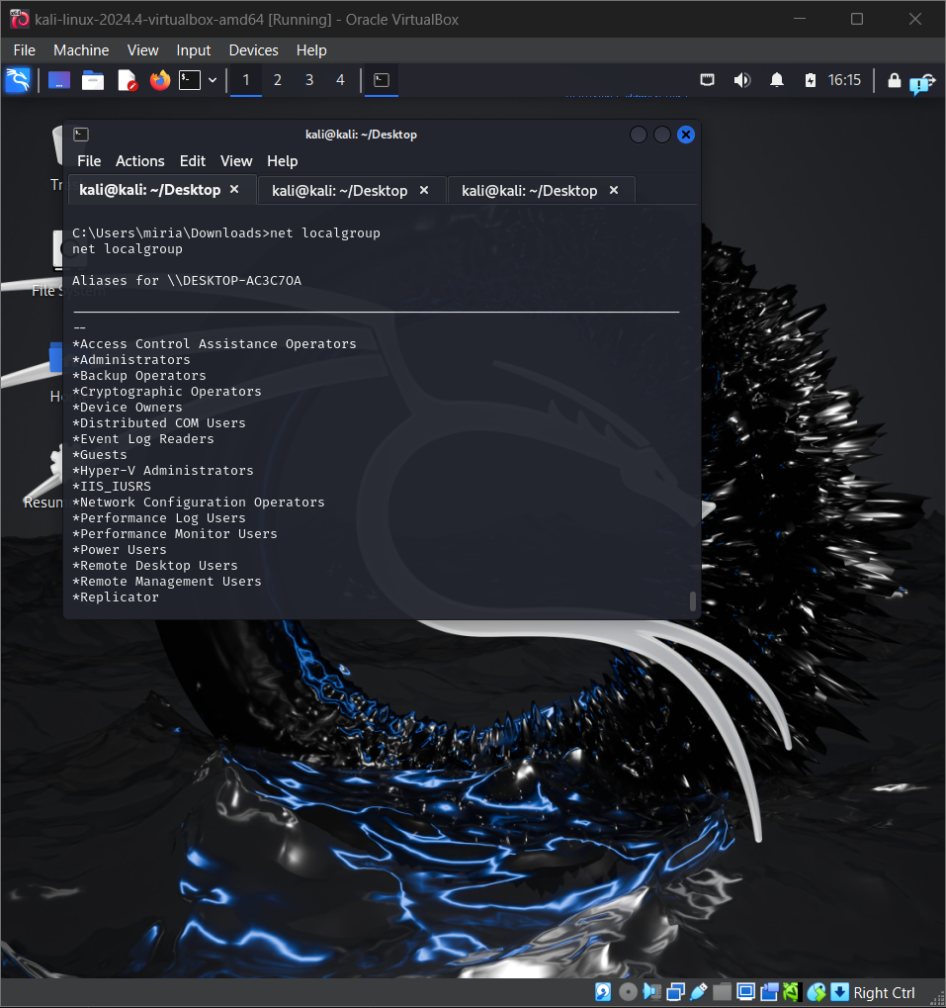

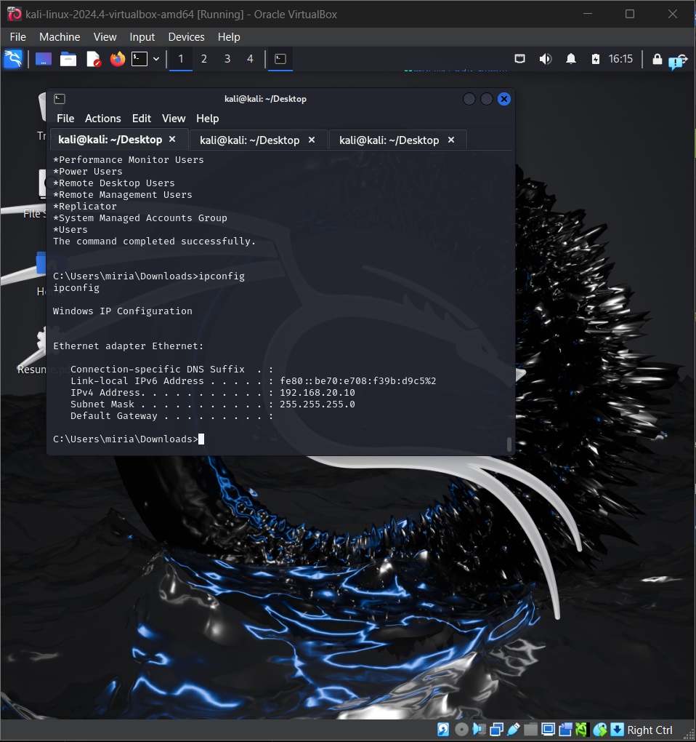

After this I went into Splunk to see what type of telemetry was generated.

Inside Splunk I went into Settings, clicked on indexes and clicked on New Index in order to create a new index called endpoint so my Sysmon logs can be injected into Splunk.

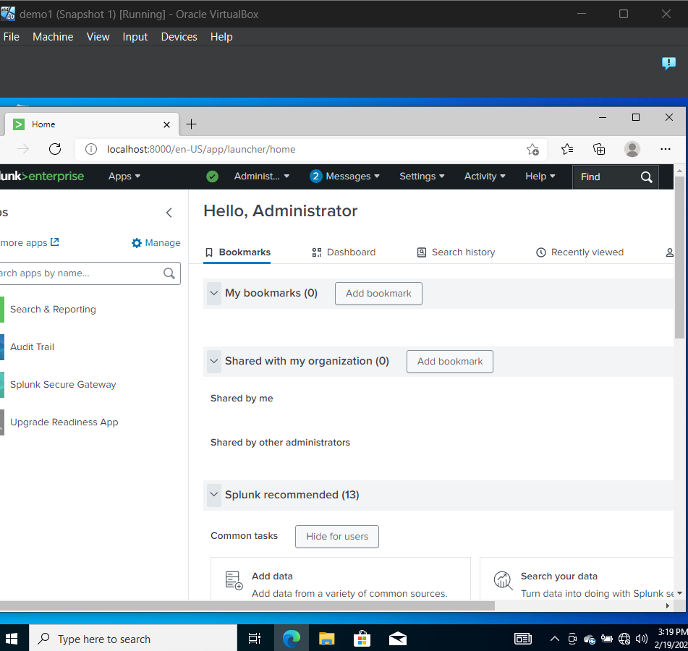

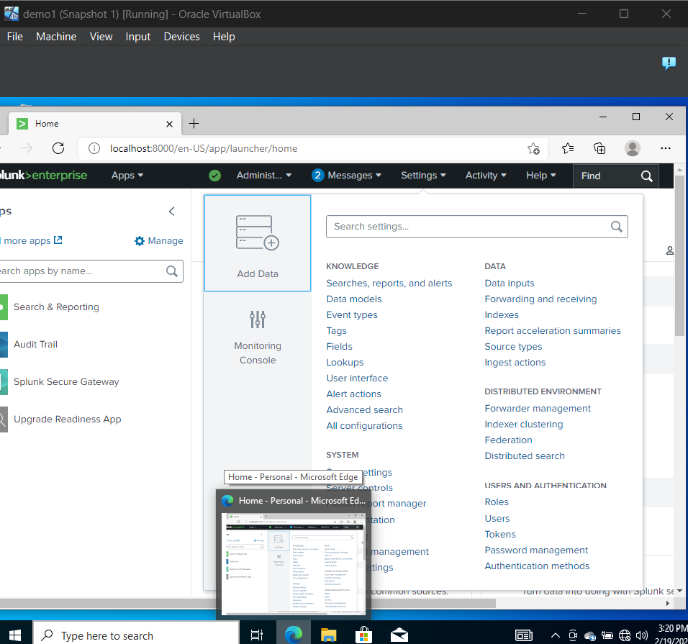

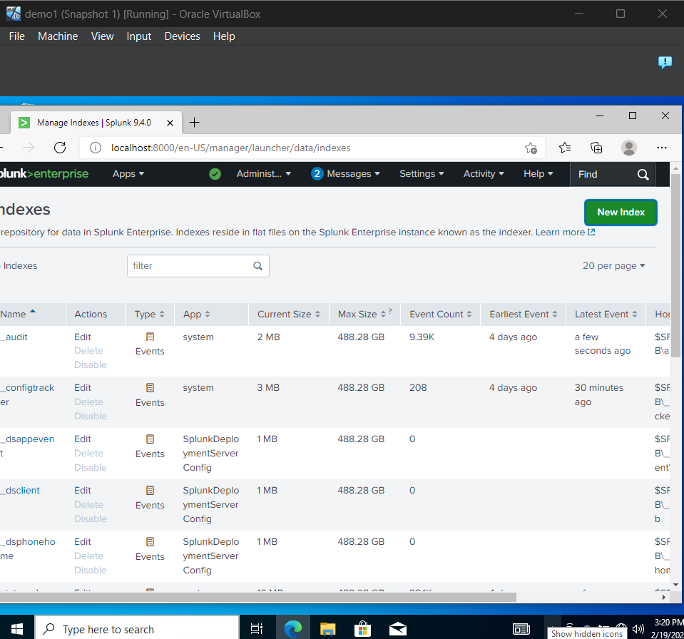

I clicked on Apps and went into Search & Reporting

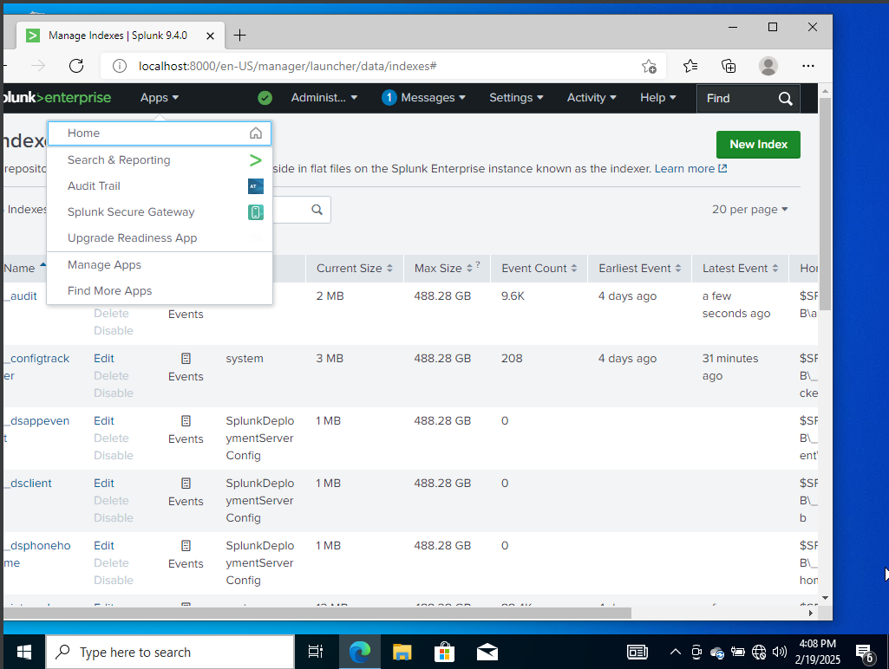

To double-check data has been ingested in Splunk I made a search for index=endpoint.

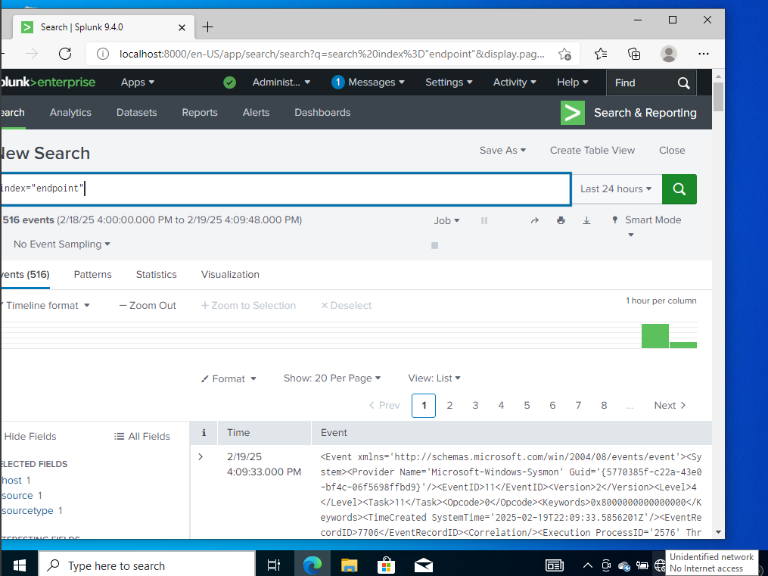

After confirming data was properly ingested I made a query for my Kali IP address 192.168.20.11

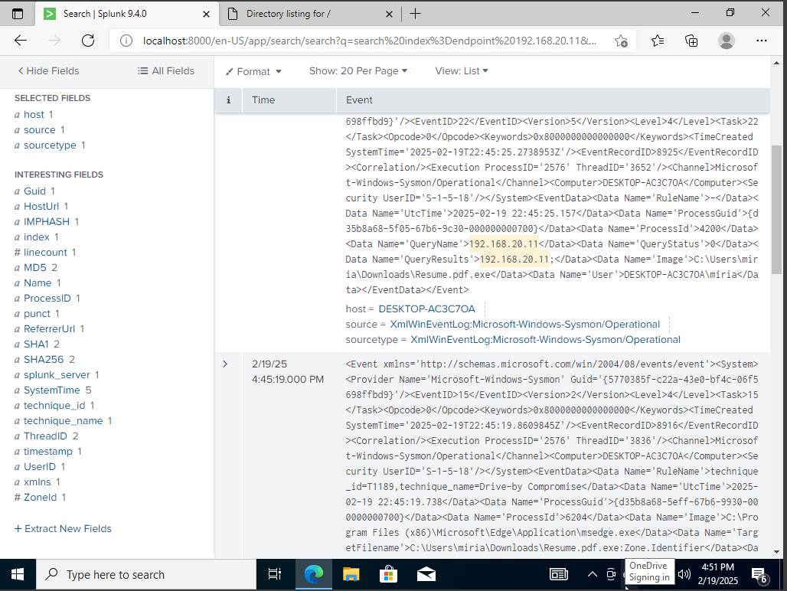

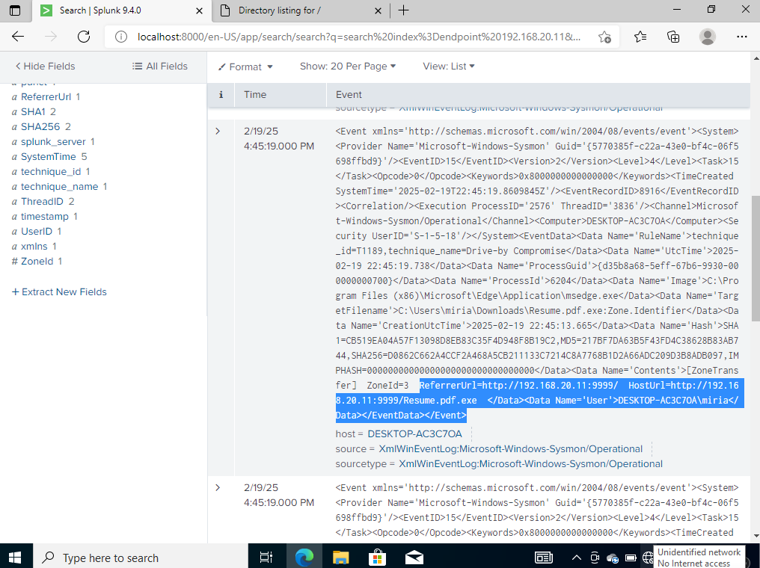

If we were analysing these logs, this would be something important to look at and analyse:

* Which machine is this?
* Why is it connecting through that port?

Now if I query my malware file Resume.pdf.exe this is what would appear and would require further investigation.

